



**X1N-H0401**

**Installation Guide**

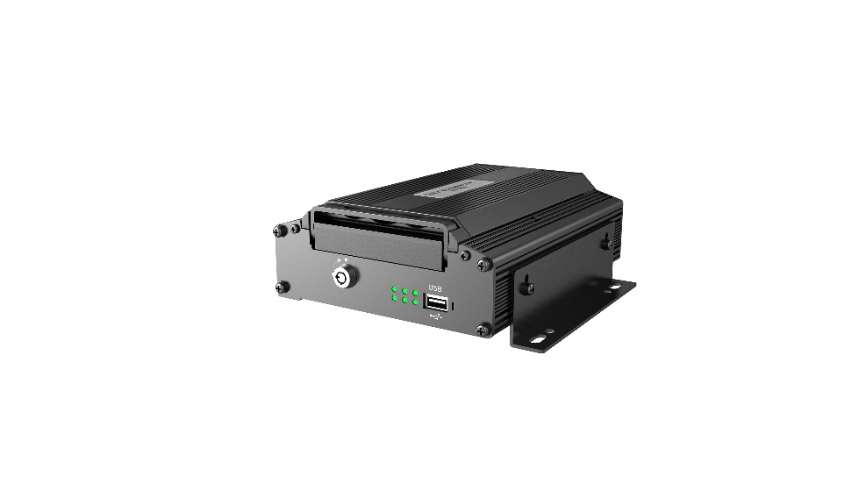

|  |  |
| --- | --- |
| **Type of document** | **General** |
| **Product planning document** | **Public** |
| **Version** | **63 pages in total** |
| V1.5 |

Revision History

|  |  |  |  |
| --- | --- | --- | --- |
| **Date** | **Revision** | **Modification Description** | **Author** |
| April 26, 2021 | V 1.0 | First draft of X1N-H0401 solution |  |
| May 10, 2021 | V 1.1 | Content optimization |  |
| September 23, 2021 | V1.2 | Supplementary precautions for the Installation of glass-mounted and countertop-mounted CA29M |  |
| October 30, 2021 | V1.3 | Modification of ADAS calibration and DMS Installation precautions |  |
| December 24, 2021 | V1.4 | Added BSD calibration |  |
| April 1, 2022 | V1.5 | Modified ADAS and DMS calibration, and added ADKIT Installation and calibration. | Zhouhao/Wangxiaoyong |

**Table of Contents**

Foreword 5

Important Instructions 5

1. System Overview 7

1.1 Product Overview 7

1.2 Schematic Diagram of Equipment Connection 7

1.3 Schematic Diagram of System Connection 7

1.4 Definition of External Cable Interface 8

2. Preparation for Installation 8

2.1 Technical Requirements for Installation 8

2.2 Understanding of Installation Environment 8

2.3 Confirmation of Vehicle Conditions and Vehicle-related Electrical Information 9

2.4 Power Supply Connection of Vehicle 9

2.5 Connection of Necessary Signal Cables 9

3. Preparation of List of Installation Materials and Tools 10

3.1 Inspection as per Packing List 10

3.2 Preparation of Installation Tools 11

3.3 Preparation of SIM Card 14

4. Installation of X1N Main Unit 14

4.1 Installation of SIM Card and Removal and Installation of Hard Disk 14

4.2 Installation of X1N Main Unit 15

4.3 Power Supply Connection and Connection of Signal Cables 16

4.3.1 Power Supply Connection 16

4.3.2 Connection of Signal Cables (Pulse/Left/Right Steering Signal/Reversing) 16

4.4 Installation of GPS, 3G/4G and WiFi Antennas 18

4.4.1 Installation of GPS Antenna 18

4.4.2 Installation of 3G/4G Antenna 18

4.4.3 Installation of WiFi Antenna 19

5. Installation and Calibration of Optional Components 20

5.1 ADAS Camera 20

5.1.1 Requirements for Installation Position 20

5.1.2 Requirements for Installation Details 20

5.1.3 Installation Steps 22

5.1.4 Calibration Requirements 23

5.2 DMS Camera 36

5.2.1 Requirements for Installation Position 37

5.2.2 Requirements for Installation Angle 38

5.2.3 Requirements for Installation Details 39

5.2.4 Installation Steps 39

5.2.5 Calibration Requirements 44

5.3 ADKIT Installation and Calibration 47

5.3.1 Requirements for Installation Position 47

5.3.2 Installation Steps 4 8

5.3.3. Calibration Requirements 49

5.4 BSD Installation and Calibration 51

5.4.1 Top-view Installation and Calibration 51

5.4.2 Side-mounted Calibration 54

5.4.3 Blind Spot in Front of the Vehicle 58

6. Process Requirements 60

6.1 Treatment Standard of Unused Connection Wire Ends 60

6.2 Connection Process of Aviation Connector 60

6.3 Requirements of Opening for Wiring 61

6.3.1 Interior Opening for Wiring of Vehicle 61

6.3.2 Exterior Opening of Car-body- Opening for Installation of Tail Harness of Camera 61

7. Acceptance and Cleaning 62

7.1 Cleaning 62

7.2 Installation Acceptance 62

Foreword

This *X1N-H0401 Installation Guide* is hereby prepared to better guide engineering personnel to install X1N-H0401 and its accessories properly and quickly, and to improve Installation efficiency.

This document mainly includes the following parts: foreword, system overview, preparation for Installation, introduction to Installation, calibration, and acceptance and cleaning.

This document is applicable to Installation engineering personnel.

Streamax Technology Co., Ltd. has the right of final interpretation for this document, and reserves the right to make corrections to this document or to make changes to the information and description herein. No prior notice will be given if there is any change.

Important Instructions

1. Before Installation, please park the vehicle on the horizontal ground and shut down the engine (do not park the vehicle on a ramp or an inclined road).

2. Please read the section of packing list carefully and check carefully at the time of unpacking.

3. Please read the section of tool list carefully and provide Installation tools before product Installation.

4. Before Installation, please observe the vehicle environment and follow the principles below:

a. The Installation position and wiring of the product shall neither affect the driver's view nor affect the adjustment of the rearview mirror and sun visor;

b. The camera lens for monitoring the road condition ahead of the vehicle must be within the working range of the windshield wiper;

c. The Installation position of the camera for monitoring the driver in the vehicle shall comply with local regulations;

d. The Installation position shall be convenient for the replacement and maintenance of TF card and SIM card.

5. The appropriate Installation position shall be selected according to the vehicle environment, and this document is for reference only.

6. The appropriate power supply connection method shall be selected according to the vehicle environment. **The connection to the power supply and all signal cables of vehicle shall be carried out by specialized personnel, as it may be dangerous for non-specialized personnel to operate the power system of the vehicle without authorization.** This document is for reference only.

7. In case of any problem in the Installation for special vehicles, please contact the product supplier in time for support.

8. Veyes App is required to debug and configure X1N-H0401 during Installation.

9. Please scan the QR code below, or search and download the Veyes APP in the App Store. After the download is completed, connect the APP to the equipment for related operations according to the prompt on the interface of the APP.

|  |  |
| --- | --- |
| IOS (Apple Store) | ForeignAndroid (Google Store) |

1. System Overview

1.1 Product Overview

X1N-H0401 is a cost-effective and functionally scalable device specially designed for vehicle video surveillance and remote video surveillance. Its features are as follows:

1. Support GPS positioning technology, allowing recording vehicle traveling trajectory in real time for background analysis;

2. Include 3G/4G, WIFI, G-Sensor and other modules, realizing various functions;

3. Support 720P and 1080P HD resolution video recording;

4. Special file system, ensuring video data security and protecting personal privacy;

5. Compliance with industrial design requirements, aluminum alloy enclosure and large-area cooling fins, ensuring good heat dissipation effect;

6. Support remote video monitoring and remote video playback;

7. Support four AHD cameras and one IPC network camera;

1.2 Schematic Diagram of Equipment Connection

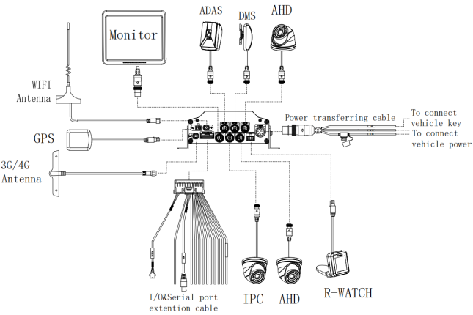

1.3 Schematic Diagram of System Connection

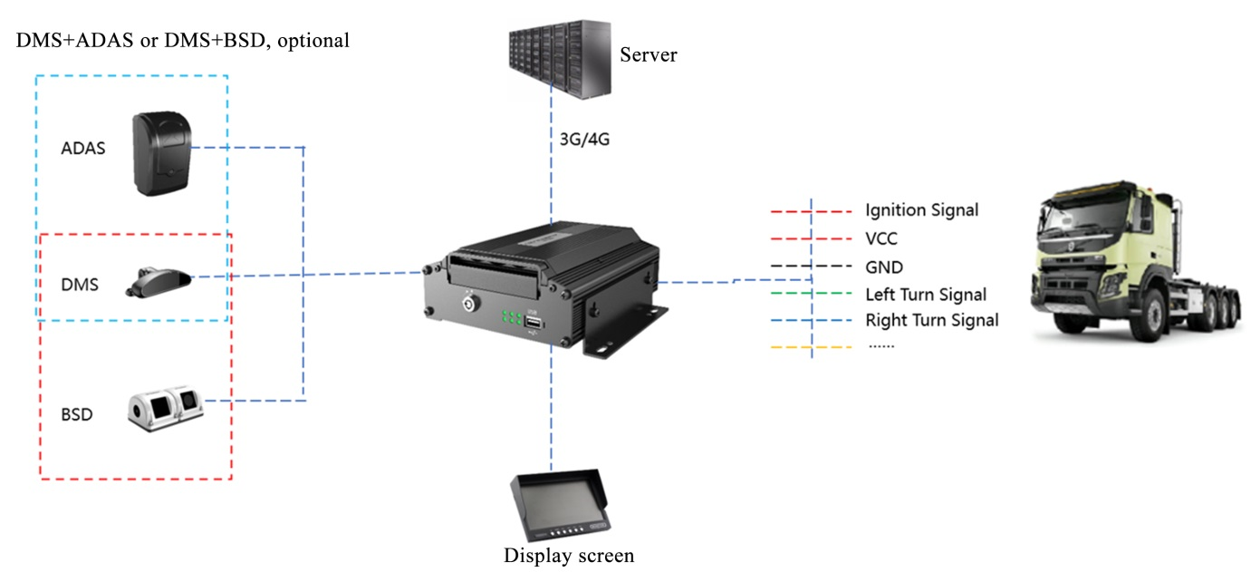

1.4 Definition of External Cable Interface

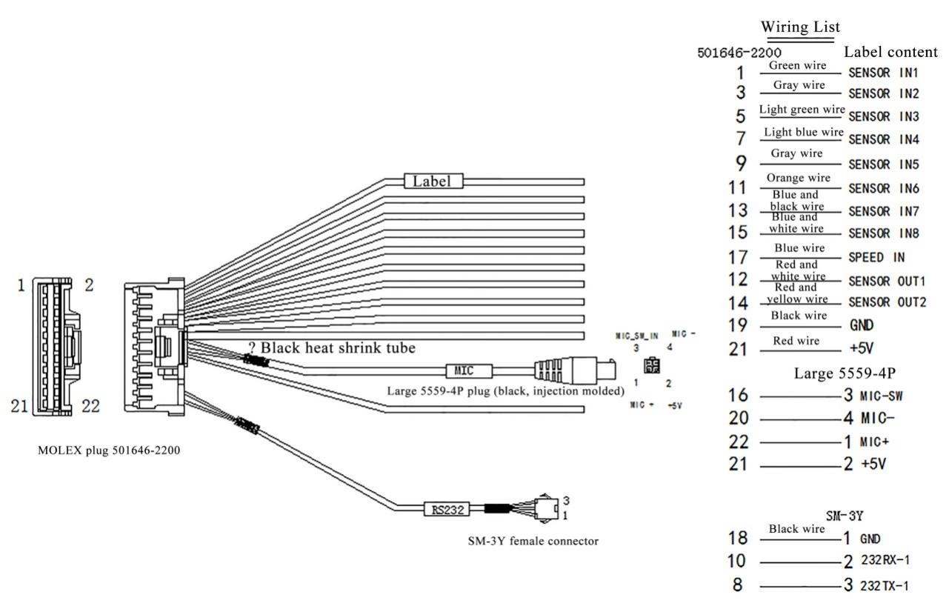

**Alarm Serial Port Cable**

2. Preparation for Installation

2.1 Technical Requirements for Installation

Relevant personnel shall be familiar with the functions, applications and the overall composition principle of the product.

Relevant personnel shall understand the electrical circuits and structure of motor vehicles, and common Installation methods of in-vehicle equipment.

2.2 Understanding of Installation Environment

Before equipment Installation, relevant personnel shall have a clear understanding of the vehicle model concerned, the Installation positions of the main unit and auxiliary cameras of the EDR, the type and length of cables required for each vehicle model, and the list of common auxiliary materials, so as to ensure successful completion of equipment Installation and commissioning.

2.3 Confirmation of Vehicle Conditions and Vehicle-related Electrical Information

Confirmation of vehicle information is the basic precondition of successful Installation and also the guarantee of division of responsibilities to avoid any damage to the vehicle. For each component, proceeding to next Step is only allowed after clear confirmation, and each operation shall be confirmed by the person in charge of the vehicle and the Installation personnel.

(1) Check the appearance and interior trims of the vehicle for any damage.

(2) Check whether the vehicle can ignite normally.

(3) Check whether the vehicle power supply system is in good condition.

*Note: Confirmation of the above information is crucial. Installation can only be carried out after the above information is considered normal through confirmation.

2.4 Power Supply Connection of Vehicle

The main unit is connected to the vehicle power supply. For specific power supply connection method, refer to 4.3 for details.

(1) Required tool: multimeter.

(2) Selection of power supply connection position

When the vehicle is shut down, use a test pencil to detect whether the circuit is live. If it is live, it is judged as a constant power supply, and then measure the voltage.

When the vehicle is shut down and is in ACC position or ignition state, use a test pencil to detect whether the circuit is live. If it is electrically neutral in shutdown state, and is live in ACC position or ignition state, it is judged as an ACC power cable, and then measure the voltage.

(3) Voltage measurement of power supply connection

Constant power supply: When the vehicle is shut down, use a multimeter to measure whether the voltage of the constant power supply cable is about 24V. If the voltage of multiple cables is about 24V in shutdown state, select the cable with higher current as the constant power supply connection cable.

ACC: When the vehicle is in ACC position or ignition state, use a multimeter to measure whether the voltage is about 24V. If the voltage is 0 in shutdown state and about 24V in ACC position or ignition state, select the cable as the ACC power supply connection cable.

*Note: During power supply connection, first conduct measurement at the positive and negative terminals of the power supply with a multimeter, to avoid wrong connection.

2.5 Connection of Necessary Signal Cables

Where required, the following signal cables must also be connected to enable the intelligent assisted driving functions of X1N-H0401:

(1) Vehicle speed pulse cable or CAN data cable - to obtain accurate vehicle speed data;

(2) Left and right steering signal cables - to obtain left and right steering information of vehicle;

(3) Brake signal cable - to obtain vehicle braking information.

Please consult the maintenance engineer of the vehicle discipline for specific position of vehicle speed pulse cable/CAN data cable. Generally, the left and right steering signal cables and the brake signal cable are arranged on the fuse board below the steering wheel or below the front passenger dashboard, and measurement for these cables can be conducted using a multimeter.

*Note: If the measured signal is a pulse signal, the source of left steering/right steering/brake signal shall be set as pulse on the setting interface of the main unit; if the measured signal is a continuous high or low level signal, the source of left steering/right steering/brake signal shall be set as level on the setting interface of the main unit.

3. Preparation of List of Installation Materials and Tools

3.1 Inspection as per Packing List

After unpacking the product, please confirm whether the EDR is intact and whether the accessories are complete.

| **List of Product Materials** | | | | |
| --- | --- | --- | --- | --- |
| **S/N** | **Picture** | **Product Name** | **Purpose** | **Qty.** |
| 1 |  | X1N-H0401 | On-board main unit with hard disk | 1 pcs |
| 2 |  | ADAS camera | Road condition detection | 1 pcs |
| 3 |  | DMS camera | Driver behavior detection | 1 pcs |
| 4 |  | BSD camera | Blind spot detection | 1 pcs |
| 5 |  | R-WATCH | Intelligent display screen | 1 pcs |
| 6 |  | CP4 | Video display screen, optional | 1 pcs |
| 7 |  | CP4 bracket | Support the display screen on a slant | 1 pcs |
| 8 |  | CP4 patch cord | Display screen patch cord | 1 pcs |
| 9 |  | CP4 extension cable | Display screen extension cable | 1 pcs |
| 10 |  | 4G antenna | 4G communication antenna | 1 pcs |
| 11 |  | Alarm serial port connecting cable | RS232 serial port with IO alarm input | 1 pcs |
| 12 |  | 9PIN power cable | Power input cable | 1 pcs |
| 13 |  | Rear shield assembly | Protect the interface connection | 1 pcs |
| 14 |  | MINI key | Unlock | 1 pcs |
| 15 |  | WIFI antenna | Enhance the WIFI signal | 1 pcs |
| 16 |  | 7.5A fuse | Socket-mounted fuse, plug-in, ordinary type 32V, 7.5A | 1 pcs |
| 17 |  | 15A fuse | Socket-mounted fuse, plug-in, ordinary type, blue case, 32V, 15A | 1 pcs |
| 18 |  | Wet and dry paper | Clean the camera lens or the windshield | 2 pcs |
| 19 |  | Standard SIM card | Dial-up, self-purchased | 1 pcs |
| 20 |  | 6PIN audio and video extension cable  (optional length) | IPC camera audio and video extension cable, optional | 1 pcs |
| 21 |  | 4PIN audio and video extension cable  (optional length) | AHD camera audio and video extension cable, optional | 1 pcs |
| 22 |  | External GPS module | High-precision positioning, required | 1 pcs |

3.2 Preparation of Installation Tools

Before Installation, the following Installation accessories and tools shall be made available.

| **List of Installation Tools and Accessories** | | | | |
| --- | --- | --- | --- | --- |
| **S/N** | **Picture** | **Name of Tool** | **Purpose** | **Qty.** |
| 1 |  | Torsion drill | Tighten screws | 1 pcs |
| 2 |  | Common screwdriver socket | Tighten screws; optional | 1 pcs |
| 3 |  | Crow plate | Pry up the vehicle panel | 1 pcs |
| 4 |  | Ties | Bundle cables | Several |
| 5 |  | Dry cleaning cloth | Clean the countertop | 1 pcs |
| 6 |  | Smartphone/pad | Install the EasyCheck App for video preview and parameter configuration | 1 pcs |
| 7 |  | Steel tape | Measure the Installation height of the forward-facing ADAS camera lens and assist the Installation in other scenarios | 1 pcs |
| 8 |  | Mark pen | Mark lines for main unit Installation | 1 pcs |
| 9 |  | Cutting nippers | Cut and strip wires | 1 pcs |
| 10 |  | Insulated rubber tape | Wrap wire ends | 1 pcs |
| 11 |  | Scissors | Cut insulated rubber tape or wire clip | 1 pcs |
| 12 |  | USB flash disk | Standby | 1 pcs |
| 13 |  | Multimeter | Locate vehicle power supply | 1 pcs |
| Measure the conduction of harness |
| Measure pulse signal |
| 14 |  | 3M adhesive tape | Fix DMS camera | 1 pcs |
| 15 |  | Rubber sleeve | Rubber sleeve at the opening for cable protection | Several |
| 16 |  | Corrugated conduit | Aesthetic wiring and cable protection |  |

|  |  |  |  |  |
| --- | --- | --- | --- | --- |
| **DMS Camera Installation Tools** | | | | |
| **S/N** | **Picture** | **Name of Tool** | **Purpose** | **Qty.** |
| 1 |  | PH2 cross screwdriver | 1. Adjust and fix the DMS camera lens at certain angle  (generally included in the DMS camera packaging)  2.Tighten the lens screws; for ADAS calibration | 1pcs |
| 2 |  | 3.5mm*25mm self-tapping screw | Fix camera; standard  (generally included in the DMS camera packaging) | 4pcs |

The following Installation tools are also required for the Installation of DMS camera if required:

The following Installation tools are also required for the Installation of BSD camera if required:

| **BSD Camera Installation Tools** | | | | |
| --- | --- | --- | --- | --- |
| **S/N** | **Picture** | **Name of Tool** | **Purpose** | **Qty.** |
| 1 |  | Wire stripper | Strip and cut wires, and cut ties | 1 pcs |
| 2 |  | Multimeter | Locate vehicle power supply  Measure the voltage of vehicle | 1 pcs |
| 3 |  | Common screwdriver  socket | Fix bracket and camera | 1 set |
| 4 |  | 20m tape measure | Ranging and calibration | 1 pcs |
| 5 |  | Electric hand drill | Drill holes on the carbody | 1 pcs |
| 6 |  | High-speed steel drill bits | Drill holes on the carbody  3.4mm and 3.8mm drill bits | Several |
| 7 |  | Tapper | Drill holes on the carbody for the concealed Installation of tail harness  18mm and 20mm drill bits | Several |
| 8 |  | A piece of steel wire | Lead wires to pass through holes | 1 pcs |
| 9 |  | EasyCheck App | Calibrate camera | 1 pcs |
| 10 |  | Ties | Put harness in order | 1 bag |
| 11 |  | 3M insulated rubber tape | Connection insulation | 1 pcs |
| 12 |  | Mini type level | Ensure that the camera is installed vertically | 1 pcs |
| 13 |  | SUPER 918A  Glass sealant | Seal holes on carbody for waterproofing | 1 pcs |

3.3 Preparation of SIM Card

To ensure normal online communication and data transmission of the equipment, please prepare a Micro SIM card that meets the quality requirements before Installation.

4. Installation of X1N Main Unit

4.1 Installation of SIM Card and Removal and Installation of Hard Disk

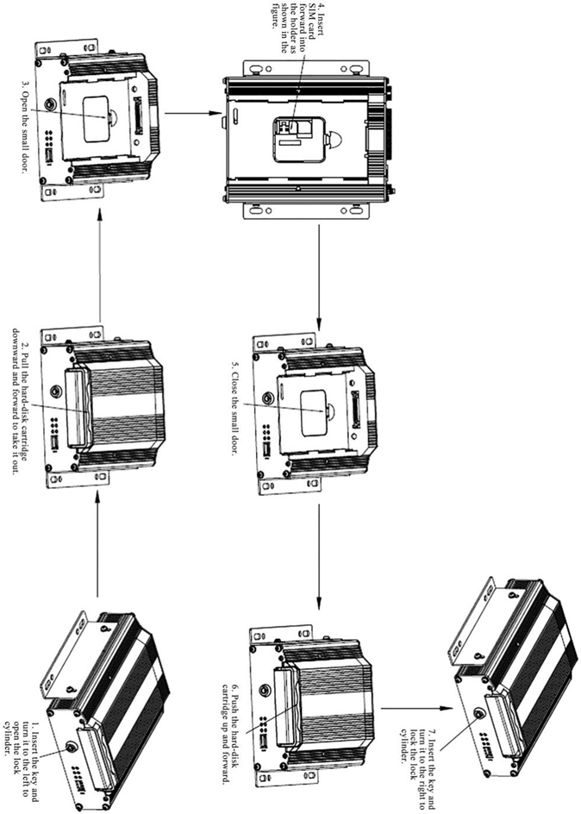

*Note:

(1) Do not touch the surface of the metal contact of the SIM card with hands when taking and installing the card, for fear of contaminating the SIM card by dust and sweat stain.

(2) Before installing SIM card, please check the surface of the metal contact of the SIM card for any dirt (such as dust, fingerprints and water stains). If any, clean the surface with a piece of non-woven fabric or rubber.

4.2 Installation of X1N Main Unit

The Installation position and method of the main unit shall be determined according to relevant electrical equipment construction specifications and on-site vehicle Installation conditions.

The Installation position shall be determined with careful consideration given to safety, vibration resistance, heat dissipation, waterproofing, damp-proofing, dust-proofing, protection against damage and easy maintenance, and shall meet the following requirements:

1. Vibration resistance: The terminal shall be installed at the position with weak vibration in the vehicle, and should be kept away from the engine.

2. Heat dissipation: The terminal shall be kept away from on-board heat sources and be installed at a ventilated position for heat dissipation.

3. Waterproofing: During Installation of the terminal, attention shall be paid to high temperature prevention and waterproofing.

4. Damp-proofing: The terminal shall be installed at a dry and ventilated place.

5. Dust-proofing: The terminal shall be installed at a place with less dust.

6. Electrical: The terminal shall be kept away from complex electromagnetic environment and strong interference environment as far as possible.

7. The Installation position of the main unit shall be flat. Keeping the main unit sidelong and on a slant shall be avoided as far as possible.

8. There shall be enough space to open and close the front panel (without affecting the removal and replacement of SIM card and SD card).

9. There shall have enough distance at the tail of the main unit to plug and unplug the aviation connector (without affecting the connection), and the tail harness must be wrapped firmly and neatly.

If the above conditions are met, the main unit can be fixed with screws. It is recommended that the main unit be installed below the rear recliner or the front passenger seat in the cabin, as shown in the figure below.

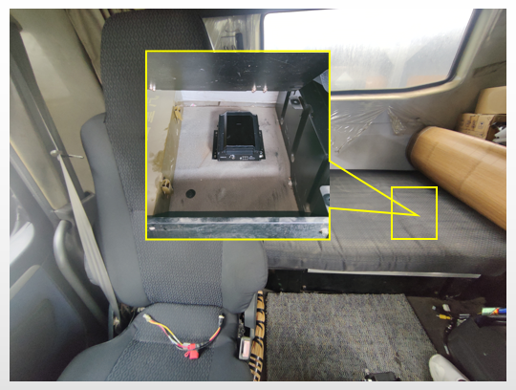

4.3 Power Supply Connection and Connection of Signal Cables

4.3.1 Power Supply Connection

Power cable: Connect DC+ to the vehicle constant power supply, ACC to the vehicle power cable, and GND to the vehicle ground wire.

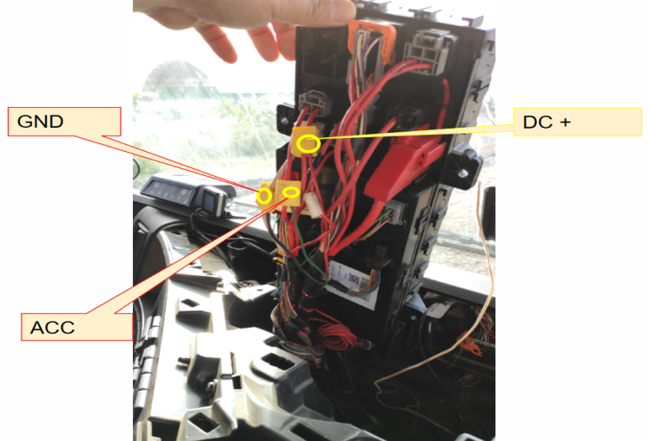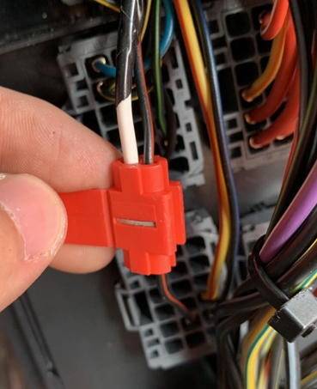

*Note:

The power cable shall be connected using "special stripping-free connection terminal" where possible (no stripping is required, so as to avoid the risk of electric leakage), and the connection shall be wrapped with insulated rubber tape to avoid electric leakage/short circuit.

If there is no special stripping-free connection terminal, stripped wires can also be used for connection. In this case, the connection process must conform to the standard specifications. After the connection is completed, the connection shall be wrapped with insulated rubber tape to avoid electric leakage/short circuit.

4.3.2 Connection of Signal Cables (Pulse/Left/Right Steering Signal/Reversing)

1. Vehicle speed pulse

Consult the maintenance engineer of the vehicle discipline to locate the vehicle speed pulse cable. In the discrete-wire alarm serial connecting cable, connect "SPEED IN" to the vehicle speed pulse cable.

After the connection is completed, log in to the EasyCheck App to connect the X1N main unit. Enter the configuration interface, and set the speed source of the equipment as "Pulse". At the same time, drive the vehicle for a short distance at the Installation site to test the accuracy of vehicle speed pulse data.

2. Left steering/right steering/reversing signal

After locating the fuse board below the steering wheel or the front passenger dashboard, measure the cable corresponding to left steering/right steering/reversing signal according to the tips on the cover back of the fuse board or using a multimeter.

There are eight IO signal cables in the discrete wire, and the signal cables such as left steering, right steering and reversing all need to be connected. Moreover, it is necessary to connect the X1N main unit through the EasyCheck App, so as to enter the configuration interface and set the use of corresponding signal cable.

① Example:To connect the SENSOR IN1 to the left steering signal cable, enter [Preferences]> [Alarm]> [Base]> [IO Alarm] interface, tick the sensor 1 Enable box, select **Left Steering** at the field of **Sensor Uses**, and **save** the setting;

② To connect the SENSOR IN2 to the right steering signal cable, enter [Preferences]>[Alarm]>[Base]>[IO Alarm] interface, tick the sensor 2 Enable box, select Right Steering at the field of Sensor Uses, and save the setting;

③ To connect the SENSOR IN3 to the reversing signal cable, enter [Preferences]>[Alarm]>[Base]>[IO Alarm] interface, tick the sensor 3 Enable box, select Reversing at the field of Sensor Uses, and save the setting;

**......**

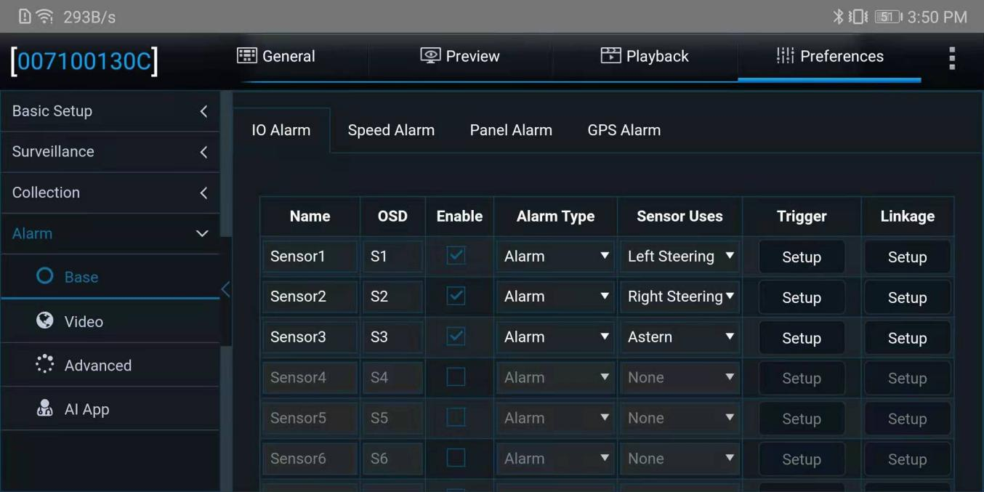

*Note:

If the measured signal is a pulse signal, the source of left steering/right steering/brake signal shall be set as pulse on the setting interface of the main unit; if the measured signal is a continuous high or low level signal, the source of left steering/right steering/brake signal shall be set as level on the setting interface of the main unit.

4.4 Installation of GPS, 3G/4G and WiFi Antennas

4.4.1 Installation of GPS Antenna

Installation requirements of GPS antenna:

1. The front side (labeling side) of the GPS antenna shall be up as required;

2. It is recommended that the antenna be installed on front passenger side, more than 10 cm away from the A-pillar.

3. There shall be no other equipment above the antenna. Moreover, the antenna shall be kept clear of in-vehicle audio-video, interphone and other electronic equipment to prevent interference;

4. The antenna Installation position shall be far away from the position with severe vibration;

5. The antenna shall be far away from the air outlet of the air conditioner to prevent condensate accumulation due to temperature change.

The GPS antenna is fixed in the vehicle.

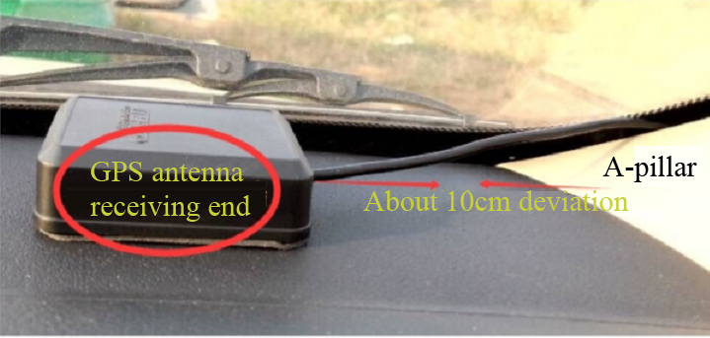

4.4.2 Installation of 3G/4G Antenna

Installation requirements:

1. The equipment that may interfere with 3G/4G signals, such as original on-board GPS positioning module, shall be kept more than 15 cm away from the antenna.

2. Excess tail harness of the 3G/4G antenna shall be concealed in the A-pillar or the center console.

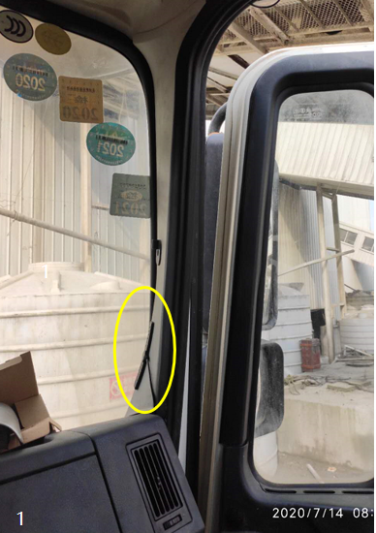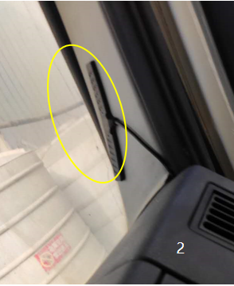

Tear off the 3M adhesive film on the 3G/4G antenna and stick the antenna under the A-pillar at the front passenger side.

4.4.3 Installation of WiFi Antenna

Tear off the 3M adhesive film on the bottom of the WiFi antenna to stick the antenna to one side of the center console of the vehicle.

Installation requirements:

1. The antenna cannot be installed in a confined space, as this may affect signal reception.

2. Excess tail harness of the WiFi antenna shall be concealed in the A-pillar or the center console.

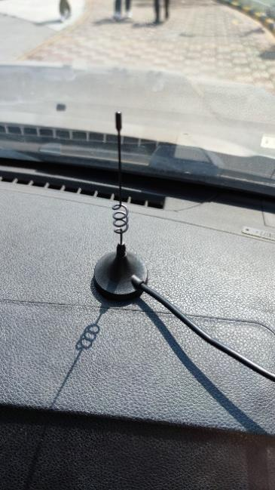

5. Installation and Calibration of Optional Components

5.1 ADAS Camera

*Before Installation and calibration of the ADAS camera, it must be ensured that the vehicle is parked on the flat ground. It is forbidden to park the vehicle on a slope or a potholed road for ADAS Installation and calibration.

5.1.1 Requirements for Installation Position

1. If conditions permit, it must be installed in the middle of the front windshield.

2. If the wiper stops at the lower part of the front windshield, the ADAS Installation position shall be at least 10 cm above the lower edge of the front windshield to avoid being covered by the windshield wiper at stop position.

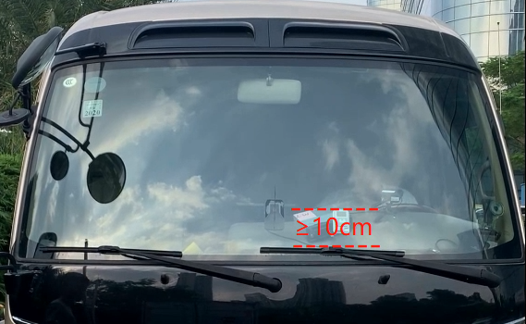

3. If the wiper stops vertically in the middle of the front windshield, the ADAS camera lens shall be installed as close to the middle position as possible (to avoid too high sensitivity for any lane deviation on this side) and be less than 10 cm away from the centerline, provided that the lens will not be covered by the windshield wiper at stop position.

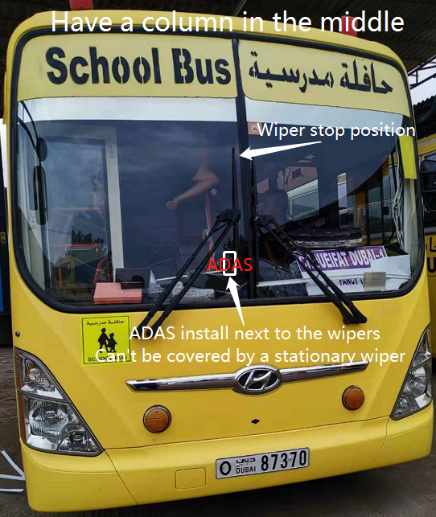

4. Make sure that ADAS is installed within the working area of the left and right windshield wipers (so as to ensure that the area within the range of the ADAS camera lens can be cleaned by the windshield wiper).

5. For ADAS, the optimum Installation height is 150 cm - 240 cm and the optional one is 120 cm - 260 cm.

5.1.2 Requirements for Installation Details

There are several methods to determine the centerline of the front windshield of a vehicle:

1. Generally, there are symmetrical air outlets on the dashboard near the front windshield. The centerline of the front windshield can be found based on the symmetry of the air outlets.

2. The centerline of the front windshield can be determined through the vehicle emblem, as shown in the figure below:

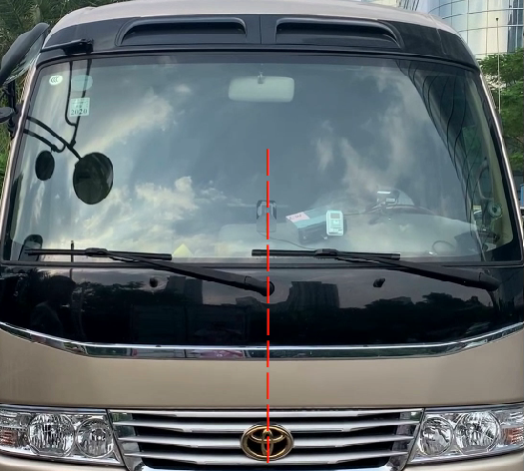

3. If the centerline cannot be determined by the above method, the following traditional method can be adopted:

Measure the width of the front windshield with a steel tape to locate the center point of the front windshield, and then locate and mark horizontal center point 1.

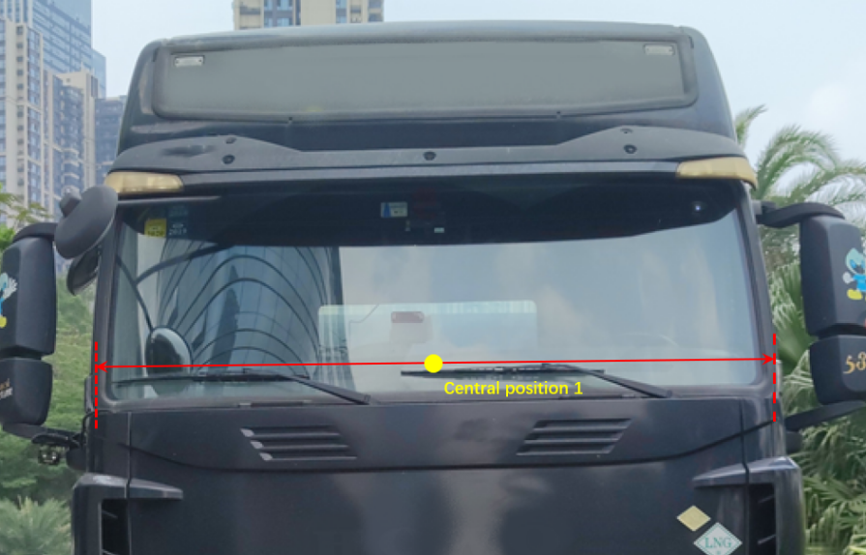

Next, in the vertical direction, locate another horizontal center point 2 on the front windshield at least 20 cm away from center point 1. Connect center points 1 and 2 with a mark pen, to draw the centerline of the front windshield.

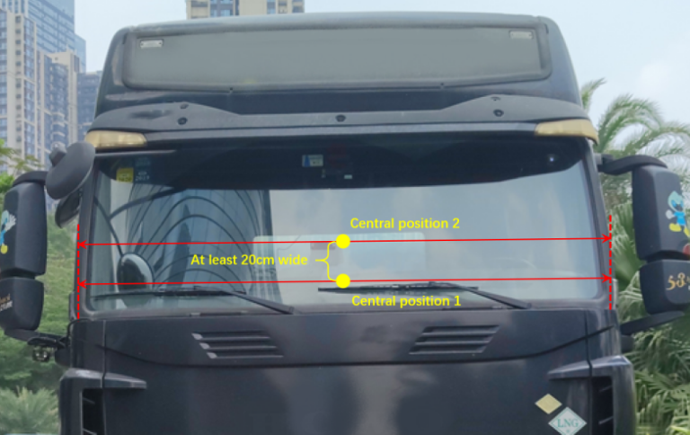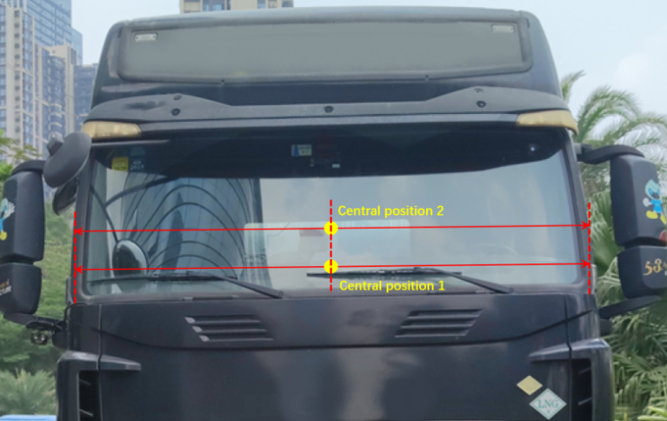

5.1.3 Installation Steps

After the Installation area and the centerline are determined, the following shall be done:

1. Clean the interior and exterior of the glass in the target Installation area with alcohol cotton in the packaging (to ensure that no dirt will affect the angle of view of the ADAS camera lens), and ensure the glass in the wiping area is dry.

2. Tear off the 3M adhesive film on the ADAS camera lens, and then stick the ADAS camera horizontally and vertically on the front windshield.

(1) If there is no special mounting bracket for ADAS Installation, it is recommended that one person should stand outside the vehicle to observe whether the ADAS camera is installed horizontally and vertically, and the person in charge of ADAS camera Installation should make fine adjustments to ensure that the camera is indeed installed horizontally and vertically, and then can press the ADAS camera tightly to ensure no bubble between the 3M adhesive tape and the glass.

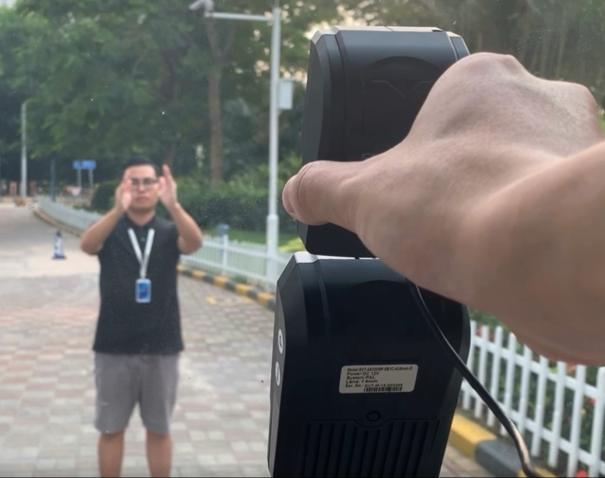

(2) If there is a special mounting bracket for ADAS (as shown in the figure below), the following steps are implemented: Place the mounting bracket vertically on the dashboard below the target Installation area, and then tear off the 3M adhesive film on ADAS, and align the lower edge of the ADAS camera to the notched ADAS fixing seat above the special bracket. Finally, press the camera onto the glass continuously to ensure no bubble between the 3M adhesive tape and the glass.

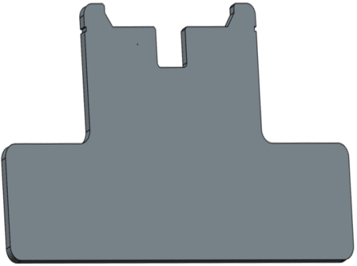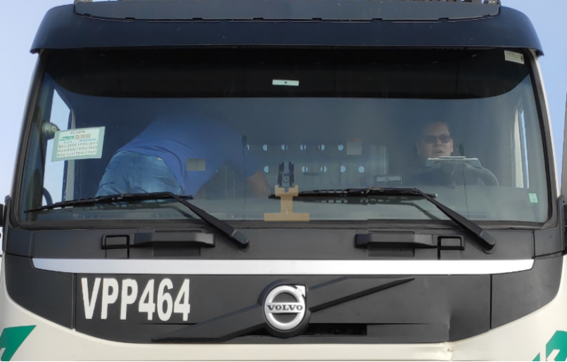

Note:The ADAS camera must be installed horizontally and vertically; otherwise, the ADAS algorithm will be greatly affected due to a skew angle of view of the ADAS screen.

5.1.4 Calibration Requirements

There are two calibration methods for ADAS—automatic calibration and manual calibration, and automatic calibration is recommended.

5.1.4.1 Automatic calibration

Calibration steps:

After the ADAS camera is installed, open its rear cover to adjust the angle of the camera lens according to the steps shown in the figures below. Make sure the following requirements are met:

1) After the auxiliary line is turned on, adjust the angle of the camera lens and make sure the horizon line is in the middle of the screen;

2) The upper and lower deviations of the horizon line from the auxiliary line in the middle of the screen shall be less than 10% of the screen width, as shown in the figure below.

|  |  |  |
| --- | --- | --- |
|  |  |  |
| 1 Remove the screw | 2 Remove the rear cover | 3 Loosen the screw to adjust the camera lens |

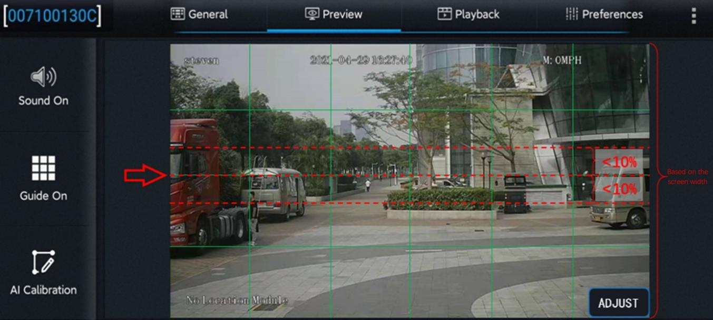

After adjustment, tighten the screws for angle adjustment and of the rear cover, and then measure the Installation height of the ADAS camera lens.

After adjusting the angle of the ADAS lens, fasten the screws for adjusting the angle of ADAS and the screws of the rear cover. Then, start measuring the mounting height of the ADAS lens.

Measure the vertical height (accurate to cm/inch) from the ground to the ADAS camera lens with a tower ruler or tape, and take it as the ADAS camera lens installation height. Measure the horizontal distance from the front view lens of AD Plus to the outermost edge of the left tire of the vehicle (standing outside the vehicle and facing the left side of the front end), and take it as the left margin of the ADAS lens. Measure the front end width (between the outermost edges of the tires on both sides) and front end length (the horizontal distance from the ADAS lens to the license plate). Refer to the following figure for the example of distance measurement.

Note: When the vertical height from the ground to the ADAS camera lens is measured, read the height value after making sure that the tower ruler or tape is perpendicular to the ground **(Note: The measuring point is the camera lens, not the upper or lower edge of the ADAS housing).**

After entering the Veyes operation interface, click [Preferences] > [Alarm] > [AI App] > [Algorithm], as shown in the figure below:

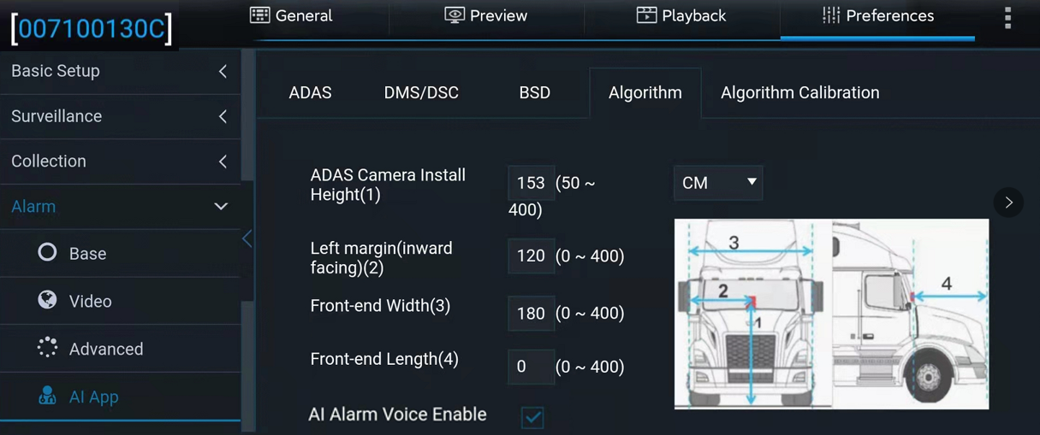

The ADAS calibration height can be in cm or in inch. In the parameter input box, fill in the read ADAS lens installation height, left margin, front end width, and front end length. Click Save after filling in the parameters.

5.1.4.2 Manual calibration

There are two manual calibration methods for ADAS:

One is the long-distance calibration method, which is suitable for an open Installation site with a flat road of at least 30m;

The other is the short-distance calibration method, which is suitable for a site of less favorable conditions with a flat road of only 5m.

The calibration steps of the two calibration methods are described below. To ensure proper calibration and ADAS recognition, please select the "long-distance calibration method", if conditions permit.

5.1.4.2.1 Long-distance calibration method (20m/30m/40m)

**Application scenario: The Installation site is open and has at least 30m flat road section. To ensure the calibration accuracy, this method is preferred.**

**Calibration process:**

Log into the Veyes APP to enable the ADAS calibration process.

1. Click [Preview] on the homepage to enter the preview interface, and then click [AI Calibration] on the lower left corner of the screen for calibration selection.

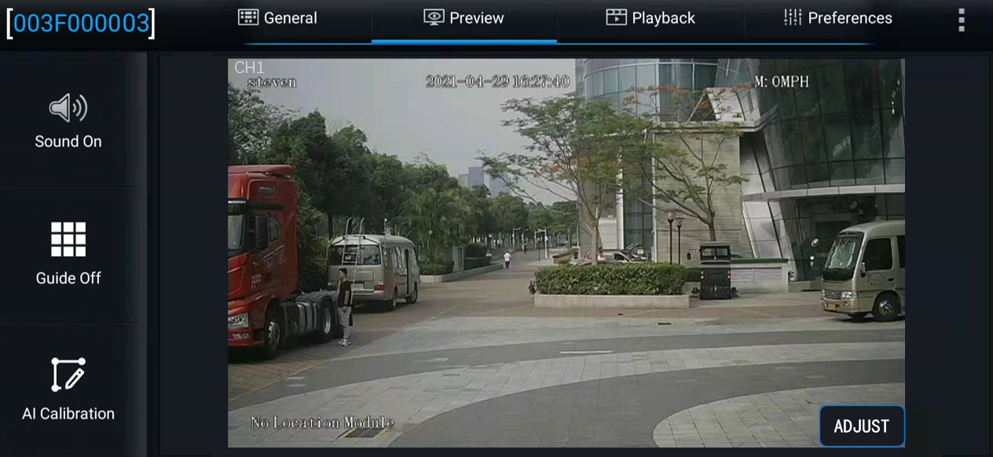

Enter the real-time preview interface and double-click the ADAS channel screen to enter the main stream, and then click "AI Calibration" at the lower left corner of the screen to enter the AI calibration selection interface for ADAS calibration.

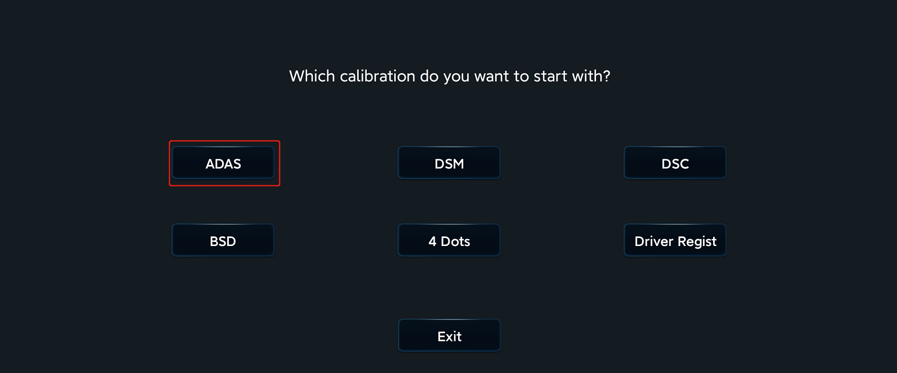

2. Select calibration channel. Since ADAS cameras are all installed in channel 1, select channel 1 here. Next, click "Calibration" at the lower right corner of the screen to enable the calibration process.

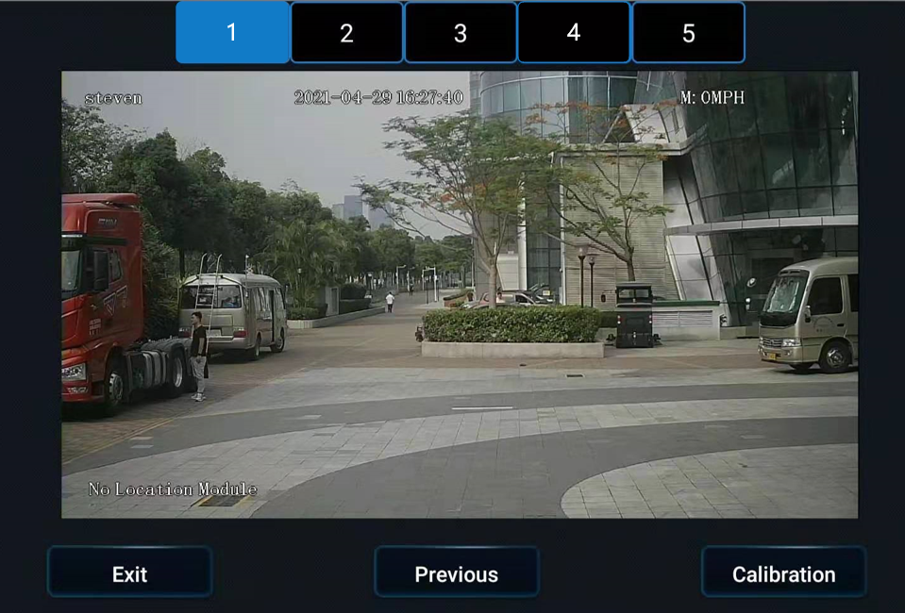

3. Confirm that the ADAS is installed at a proper position of the front windshield and within the working range of the wipers, and then click [Next]

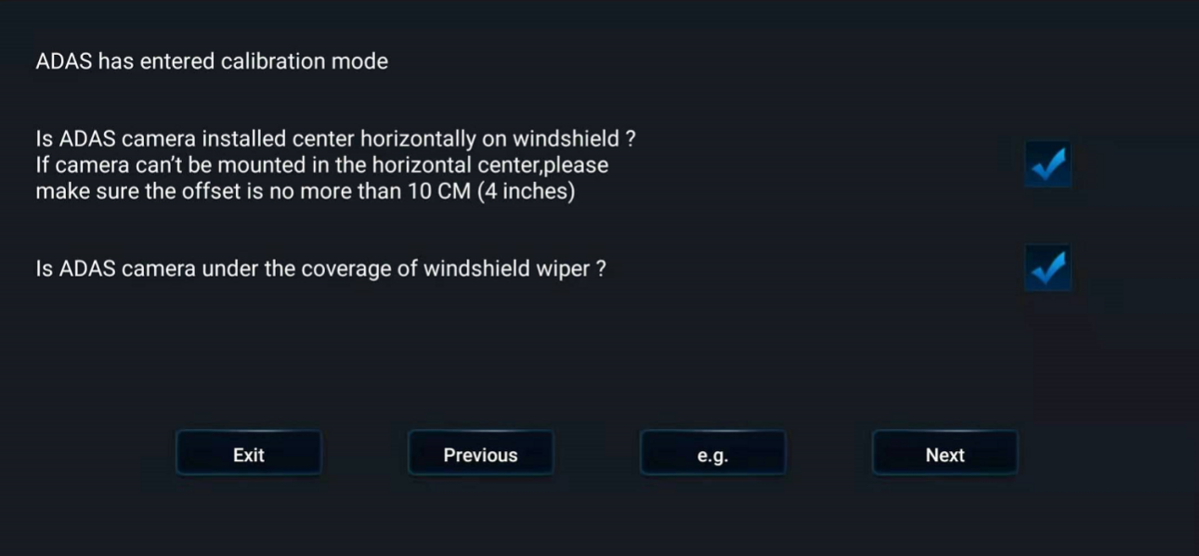

4. In the manual calibration process of ADAS, measure the Installation height of ADAS (the height of the camera lens to the ground, accurate to cm/inch, measured with the same method adopted in automatic calibration), and enter the value in the EasyCheck interface. Meanwhile, to ensure the accuracy of ADAS algorithm recognition, 3 other parameters also need to be entered in this interface: the left margin of the ADAS camera lens, and the width and the length of the vehicle head. The measurement methods of the three parameters are:

Left margin of the ADAS camera lens: the horizontal distance from the ADAS camera lens to the outermost edge of the left tire (when viewed outside the vehicle and facing the left side of the vehicle head);

Width of the vehicle head: the distance between the outermost edges of the tires on both sides;

Length of the vehicle head: the horizontal distance from the ADAS camera lens to the license plate. Refer to the figure below for the example of distance measurement

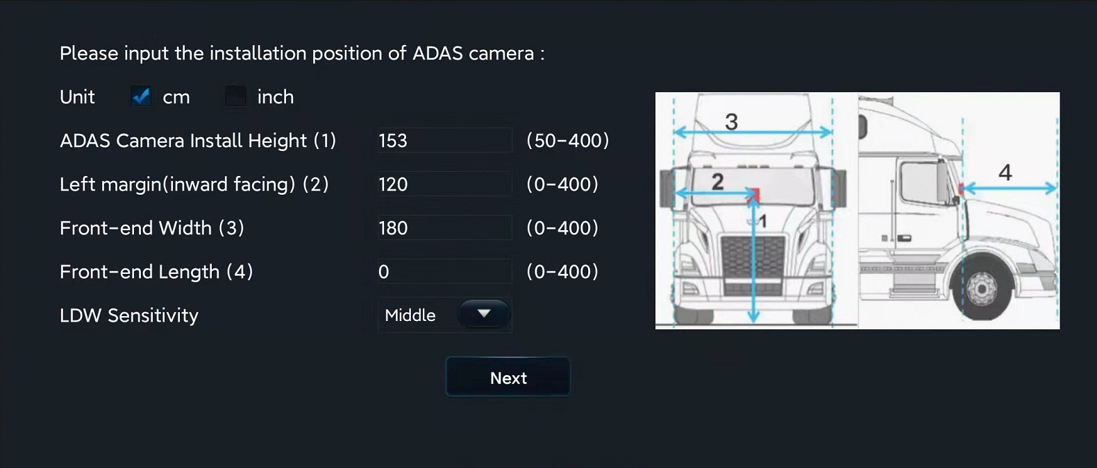

Enter the 4 parameter values measured in the EasyCheck interface, and click [Next].

5. Enter the interface shown below. In this interface, you can watch the ADAS calibration tutorial. If you already know how to calibrate, click [Next].

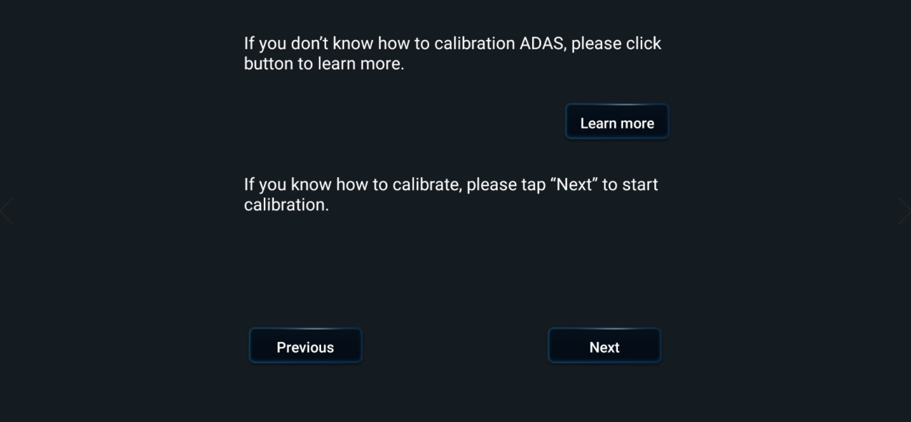

Measure distances of 20m and 30m from Point C, the point on the ground correspondent to the ADAS camera lens, in the direction parallel to the vehicle body in front of the vehicle with a leather tape. Make obvious marks at the 20m and 30m mark points, respectively. Rods are recommended for marking;

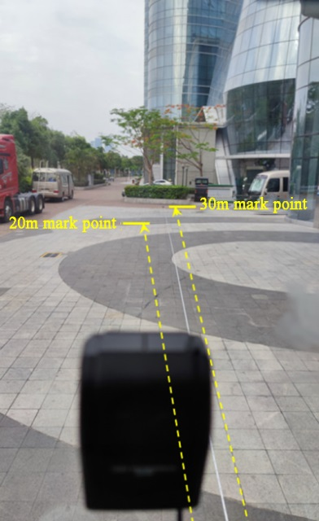

Click [Next] to enter the following interface and start to manually calibrate the ADAS camera lens.

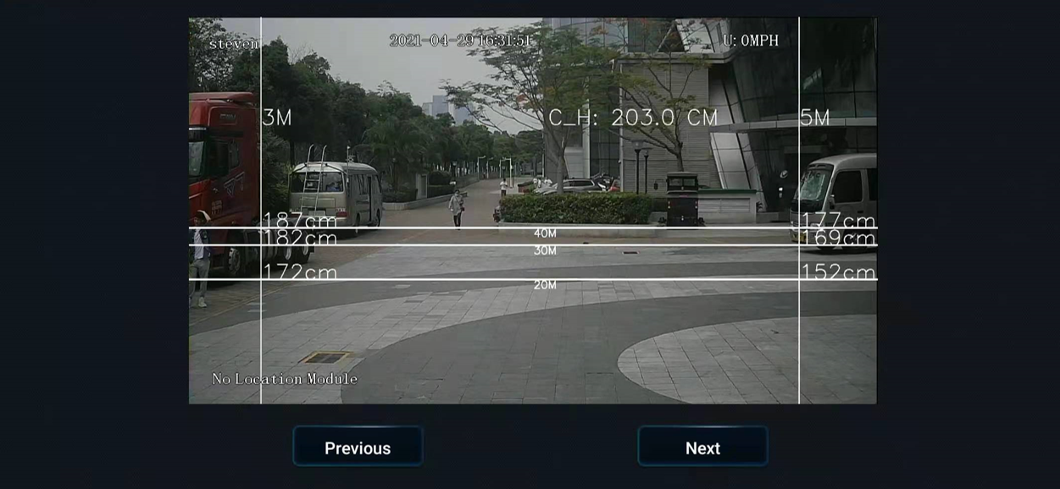

Open the back cover of ADAS camera and adjust the angle of ADAS lens to make the 20m calibration line in ADAS calibration screen coincide with the mark point at 20m on the ground, and the 30m calibration line in ADAS calibration screen coincide with the mark point at 30m on the ground.

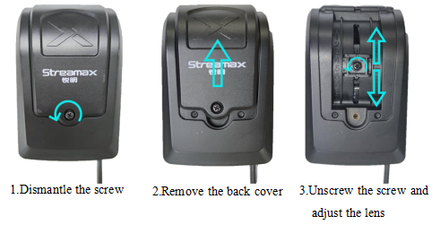

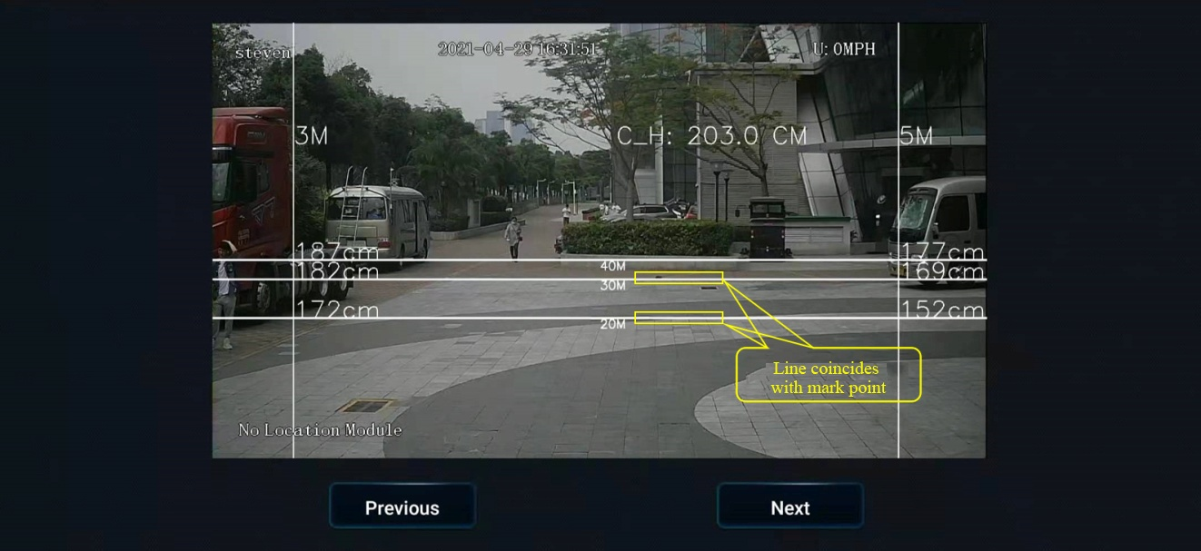

6. After that, click "Next", select the source of speed according to the actual Installation situation, set the left and right turn signal parameters, and then click "Next". In the next interface, check whether the left and right turn signals are valid according to the prompts. After checking, click [Complete] to exit the calibration interface.

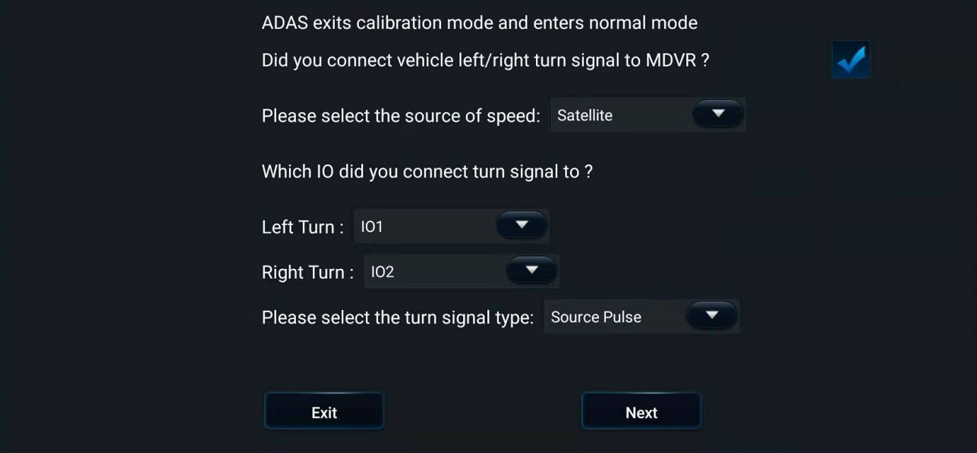

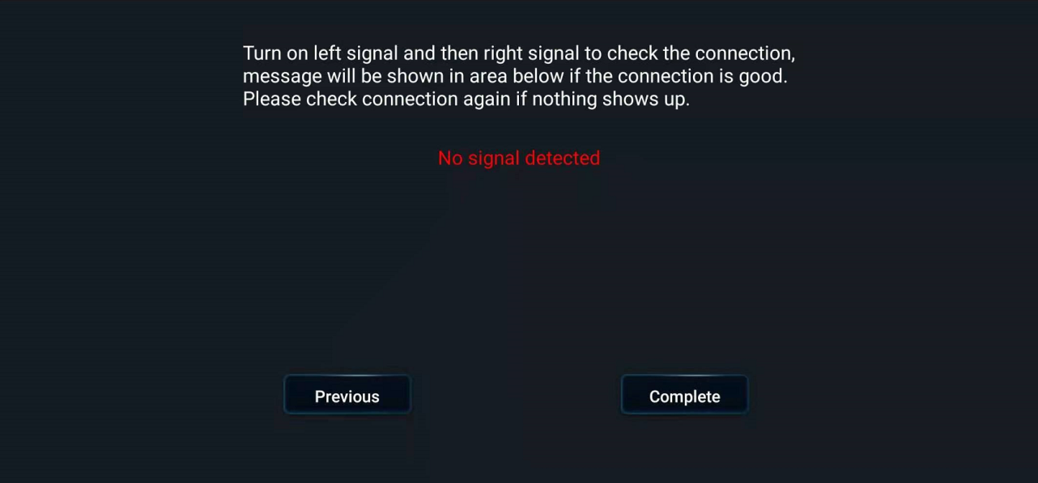

7. Go back to the real-time preview interface of ADAS channel (double-click the ADAS channel screen to enter the main stream), and check that there is no calibration line superimposed on the screen at this time, which means that ADAS channel has returned to normal mode at this time.

At this point, tighten the screws for adjusting the ADAS angle and the screws of the back cover to complete the long-distance calibration.

5.1.4.2.2 Short-distance calibration method (3m/5m)

**Application scenario: The space of Installation site is limited, but there is at least 5m flat road surface.** Although 3m or 5m can be selected for short-distance calibration, 5m is preferred in order to ensure calibration accuracy. The following is introduced with short-distance calibration (5m).

**Principle of short-distance calibration:**

When the long-distance calibration method is used, a mark point (point K as shown in the figure below) will be set 20m/30m/40m forward from the point of the ADAS lens (point A as shown in the figure below) to the ground (point C as shown in the figure below), and the 20m/30m/40m calibration line in the ADAS screen will be adjusted to match the corresponding mark point on the ground.

In case of short-distance calibration, it is limited by the environment of the Installation site, and it is impossible to set mark points at 20m/30m/40m. According to the principle of similar triangle, when a telemeter rod is set at 3m/5m (as shown at point F below), corresponding height |HF| of line AK can be found on the telemeter rod. In this way, the 20m/30m/40m calibration line in the calibration screen can coincide with the mark point H on the telemeter rod at point F by adjusting the angle of ADAS lens, and thus long-distance calibration can be realized in case of short-distance calibration (3m/5m). The calculation method is as follows:

As shown in the following figure, mark the position of ADAS camera lens as A, the projection position of A on the ground as point C, the setting position of telemeter rod as point F, and the 20m or 30m mark point in the long-distance calibration method as point K.

Take |CF|=5m and |CK|=20m as an example:

C. With F and K in the same straight line, |CF|=5m and |CK|=20m, |AC| can be measured and taken as 203cm, and thus |HF| can be obtained according to the similar triangle formula.

|HF|/|AC|=|FK|/|CK|

Then, |HF|=(|AC|*|FK|)/|CK|, and |HF|=152.25cm after plugging in the values.

This means that the effect of setting the 20m calibration line on the ground can also be achieved, provided that a telemeter rod is placed 5m in front of the ADAS lens, the height position (152cm) on the telemeter rod is marked, and the angle of the ADAS lens is adjusted to make the 20m calibration line in the calibration screen coincide with the height position (152cm) on the telemeter rod.

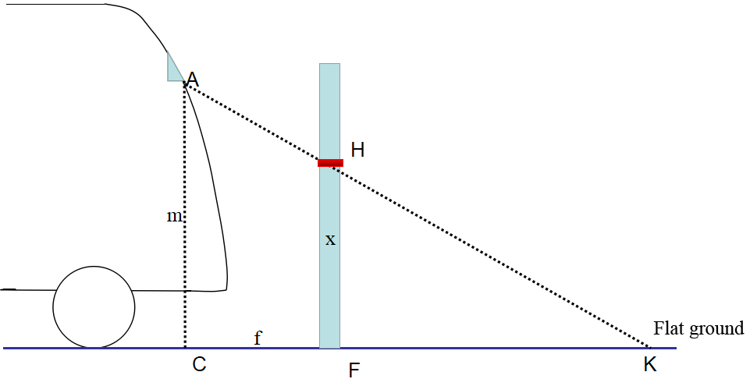

Note: The software will automatically calculate the mapping height of 20m/30m/40m calibration line on the telemeter rod according to the above principle of similar triangle when the telemeter rod is set at |CF|=3m/5m respectively, as shown in the following figure.

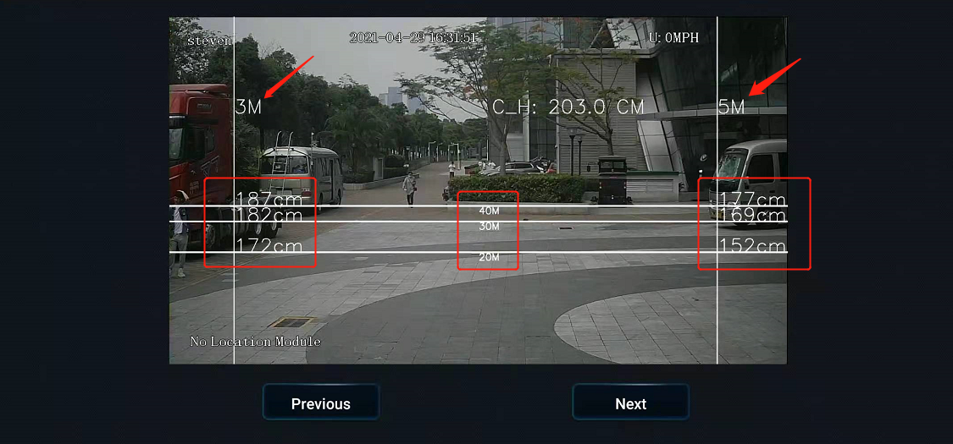

**Calibration process:**

Log into the Veyes APP to enable the ADAS calibration process.

1. Click [Preview] on the homepage to enter the preview interface, and then click [AI Calibration] on the lower left corner of the screen for calibration selection.



Enter the real-time preview interface and double-click the ADAS channel screen to enter the main stream, and then click "AI Calibration" at the lower left corner of the screen to enter the AI calibration selection interface for ADAS calibration.



2. Select calibration channel. Since ADAS cameras are all installed in channel 1, select channel 1 here. Next, click "Calibration" at the lower right corner of the screen to enable the calibration process.



3. Confirm that ADAS is installed at a reasonable position on the front windshield and is within the working range of the windshield wiper.

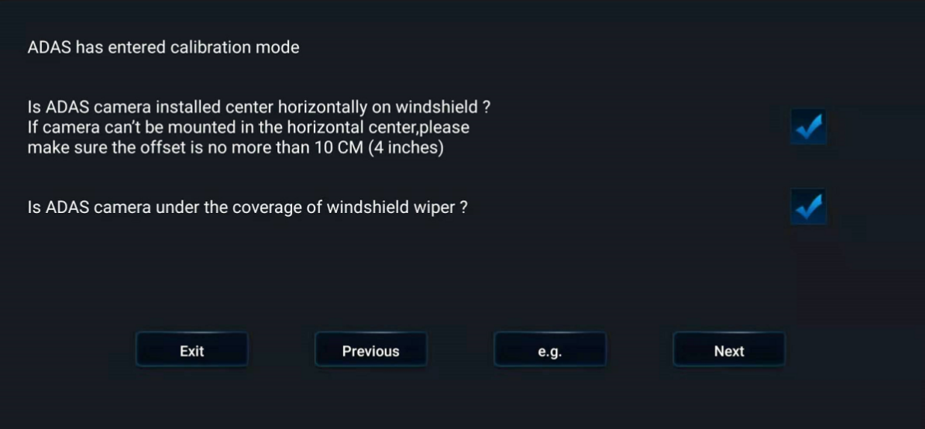

4. Measure the ADAS Installation height, the left margin of the ADAS camera lens, and the width and the length of the vehicle head. The measurement methods of these four parameters are the same as those in long-distance calibration, and will not be repeated here.

Enter the 4 parameter values measured in the EasyCheck interface, and click [Next].



5. Pull a 5m line forward from the point of the ADAS lens to the ground in the direction parallel to the vehicle body, set the telemeter rod with height scale at 5m vertically, and read the value at the intersection of the horizontal 20m calibration line and the vertical 5m calibration line in the ADAS screen, which is 152cm. Then set an obvious mark point at 152cm on the telemeter rod. It is recommended to use a conspicuous rod for marking.

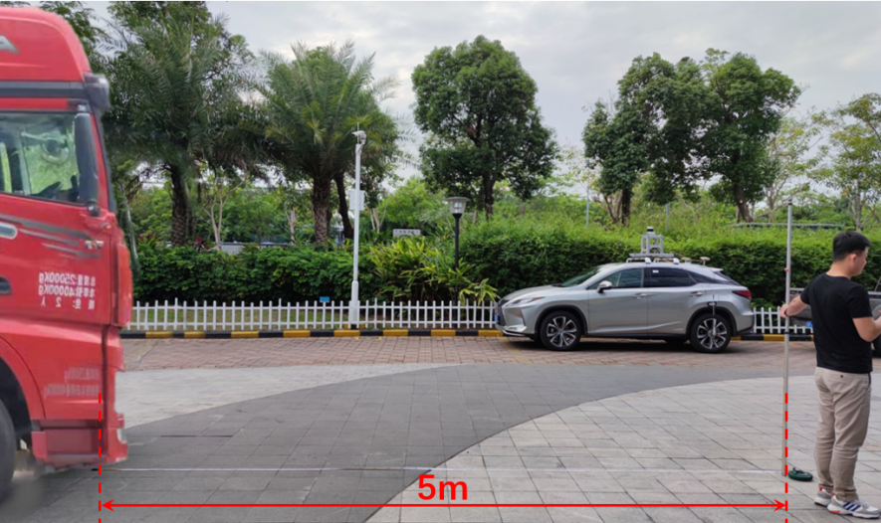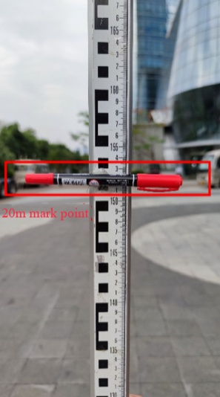

6. Open the back cover of ADAS camera, and adjust the angle of ADAS lens to make the 20m calibration line in ADAS calibration screen coincide with the mark point at 152cm on the vertical telemeter rod at 5m.

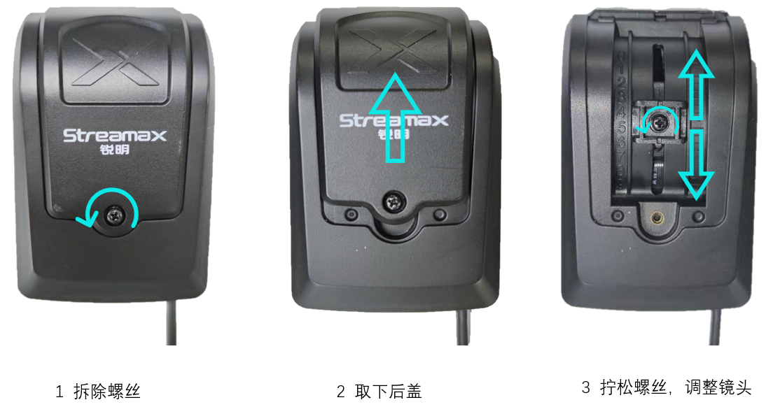

1.Dismantle the screw

3.Unscrew the screw and adjust the lens

2.Remove the back cover

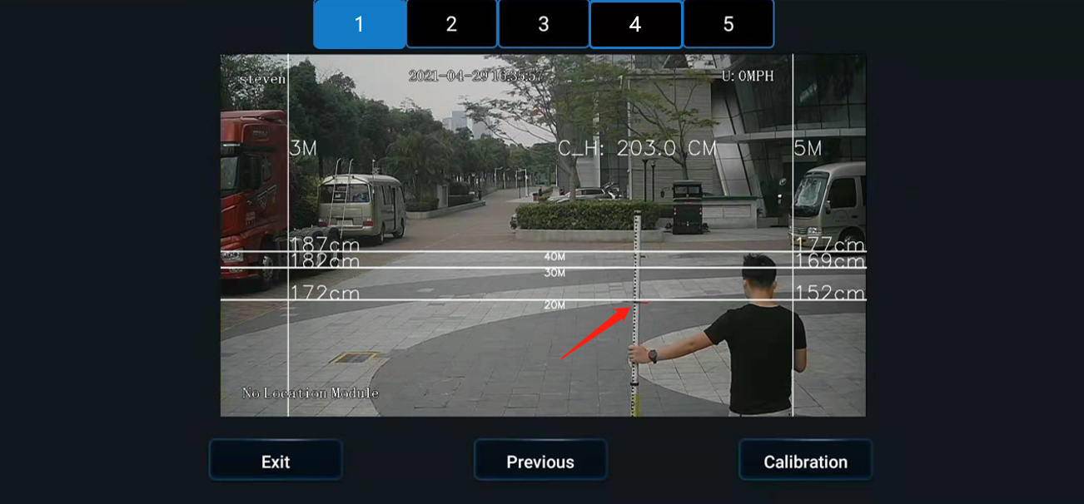

7. After that, click "Next", select the source of speed according to the actual Installation situation, set the left and right turn signal parameters, and then click "Next". In the next interface, check whether the left and right turn signals are valid according to the prompts. After checking, click [Complete] to exit the calibration interface.





8. Go back to the real-time preview interface of ADAS channel (double-click the ADAS channel screen to enter the main stream), and check that there is no calibration line superimposed on the screen at this time, which means that ADAS channel has returned to normal mode at this time.

At this point, tighten the screws for adjusting the ADAS angle and the screws of the back cover to complete the short-distance calibration.

5.2 DMS Camera

For different usage scenarios, three types of DMS cameras connected externally to ADPlus can be selected at present: A-pillar side mounted CA29M, A-pillar side glass mounted CA29M, and countertop mounted CA29M.

The three cameras are as follows:

|  |  |  |
| --- | --- | --- |
| A-pillar side mounted CA29M  (Focal length: 3mm& 4mm) | A-pillar side glass mounted CA29M  (Focal length: 3mm& 4mm) | Countertop mounted CA29M  (Focal length: 4mm) |
|  |  |  |

Generally, customers can choose A-pillar side mounted CA29M or countertop-mounted CA29M according to the actual situation. However, since some vehicles have airbags on the A-pillar, there will be hidden dangers if the camera is fixed on the A-pillar. In this case, CA29M with glass mounting bracket can be chosen and fixed next to the A-pillar. Or the front-end personnel can guide the customer to choose countertop mounted CA29M.



5.2.1 Requirements for Installation Position

1. When the A-pillar side mounted or A-pillar side glass mounted CA29M camera is selected, the camera should be adjusted to be vertical; when the countertop mounted CA29M is selected, the camera should be adjusted to be horizontal.

2. Distance from the DMS camera lens to the driver's face (the above three CA29M cameras):  
3 mm camera lens: It is suitable for scenarios where the distance from the camera lens to the driver's face is 40~80cm, and the recommended Installation distance is 50~70 cm;  
4 mm camera lens: It is suitable for scenarios where the distance from the camera lens to the driver's face is 70~100 cm, and the recommended Installation distance is 70~90 cm.

**3. The height of the above three DMS cameras after Installation must be lower than that of the driver’s face, and the camera lens must have a low angle of view.** In principle, the closer the DMS camera is to the instrument panel, the larger the low angle of view will be, which is favorable. However, the DMS camera can be installed at a higher position, so that it won't be obstructed by the steering wheel.

For large trucks, the recommended Installation height range of the DMS camera lens on the A-pillar or the front windshield is from the highest point of the steering wheel to 10 cm above the highest point of the steering wheel.

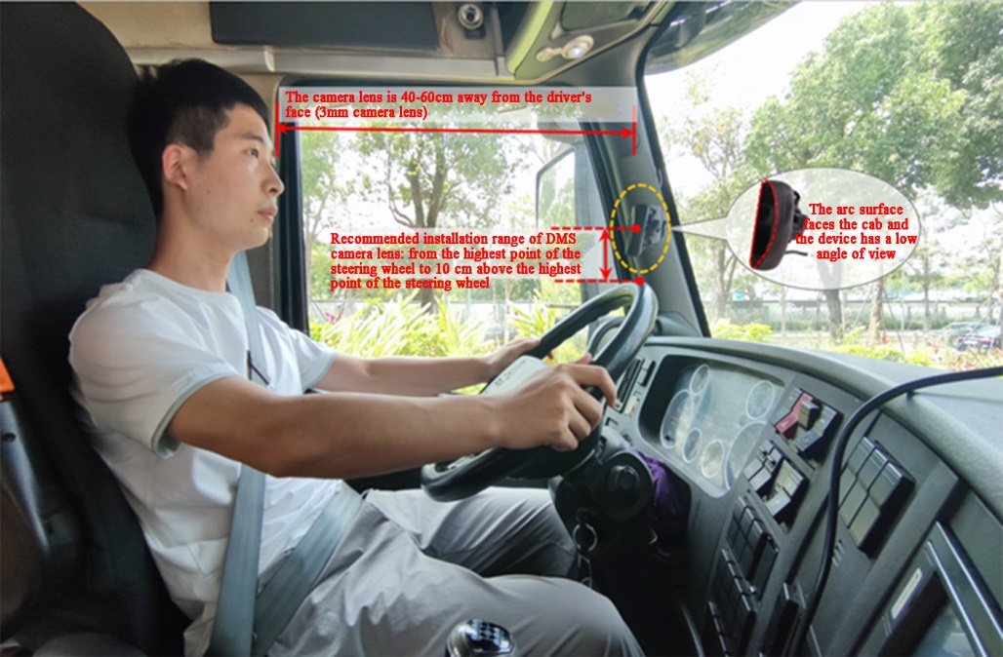

5.2.2 Requirements for Installation Angle

After the device is powered on, perform the adjustment with the assistance of the real-time preview screen. It is allowed to turn on the auxiliary line to facilitate positioning.

1. Make sure that the DMS camera has a low angle of view.

2. Adjust the DMS camera to ensure that the driver's face appears in the middle of the video screen, and the lower edge of the screen is below the driver's chest.

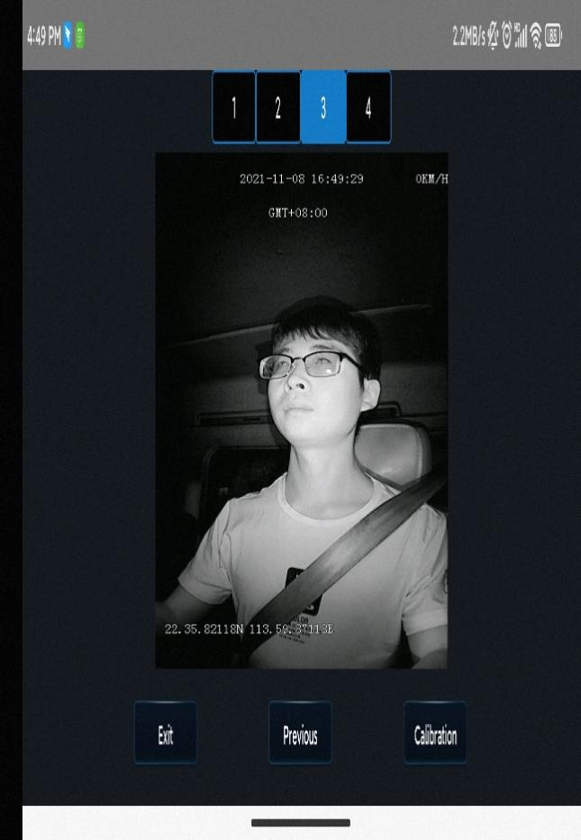

3. Make sure that the fill light of the DMS camera illuminates the driver's face (fill light illuminating the seat belt is not allowed; otherwise, it will lead to overexposure of video).

4. Make sure that there is no other object (for example, the steering wheel) in the DMS video screen that will obstruct the driver's face and the seat belt features.

5.2.3 Requirements for Installation Details

1. If A-pillar Installation (3mm lens, crescent CA29M, with side mounting bracket) or A-pillar side glass mounting bracket Installation (3mm lens, crescent CA29M, with glass mounting bracket) is adopted, the labeling surface of DMS camera must face toward the A-pillar (with the arc side facing toward the driver).

2. In the event of Installation on countertop (4mm lens, crescent CA29M, with vertical mounting bracket), the labeling surface of the DMS camera must face downward (with the arc side facing upward).

3. After angle adjustment and calibration, the protective film on the DMS camera must be removed, and the DMS camera must be locked with a socket head wrench to avoid shaking.

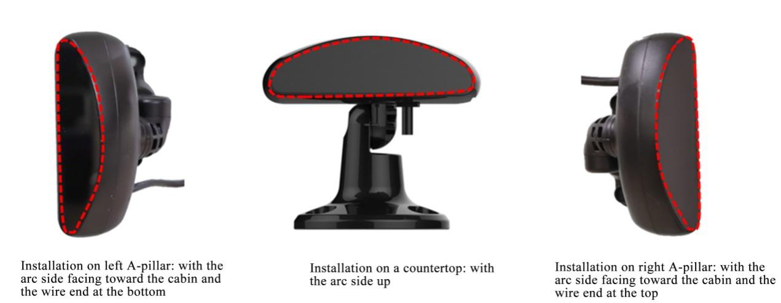

5.2.4 Installation Steps

5.2.4.1 Installation steps of A-pillar CA29M camera

1. Energize the device, connect the device through the APP, and enter the real-time preview screen. After that, check whether the driver is upright in the screen when the device is installed at the target position and the camera label faces the direction of the A-pillar (with the arc surface facing the driver).

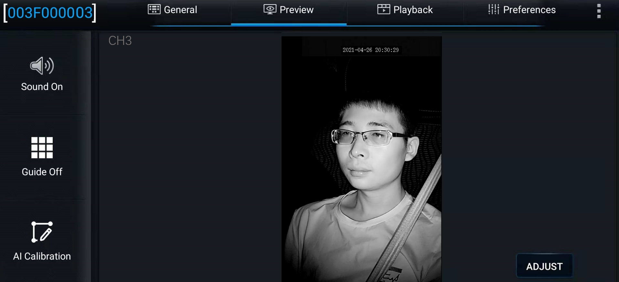

2. If the screen is upright, there is no need to set the Installation type of the DMS camera, and go directly to Step 3;

If the driver is upside down or skewed on the screen, select the channel corresponding to the DMS camera (the Channel 3) by clicking [Preferences]>[Surveillance]>[Camera Setup] , and modify the rotation angle, mirroring, and flipping parameters on the right side of the screen to adjust the DMS channel screen. Generally speaking, the Installation angle parameter should be set to 0 for countertop-mounted CA29M. If the screen of external 3mm A-pillar side-mounted CA29M is skewed, the Installation angle parameter needs to be modified from 0 to - 90° or +90°.

*Note: Do not activate Mirroring or Flipping, please make sure that Mirroring and Flipping settings are both No.

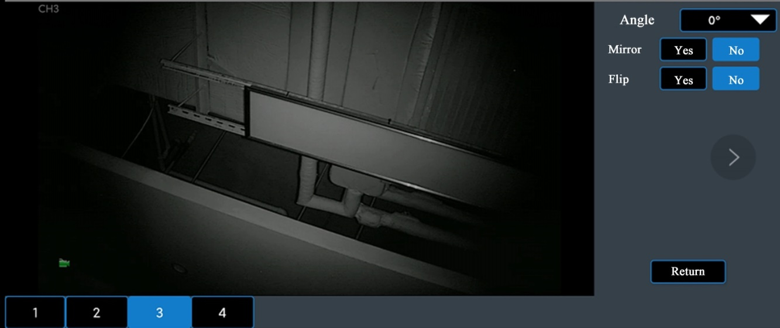

3. After the appropriate Installation position meeting the above requirements for Installation details is determined through the DMS camera screen, first tighten the upper screw of the DMS camera mount (with the lower screw of the mount not tightened temporarily, so as to adjust the angle of the camera up and down).

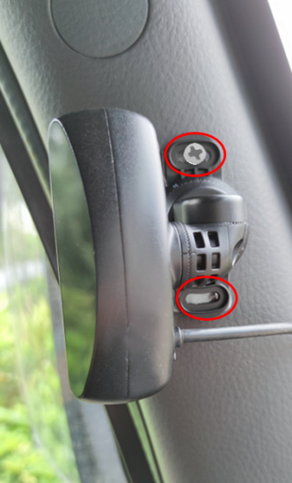

4. Adjust the left and right angle joints of the DMS camera through the hexagon socket screws, so as to adjust the angle of the DMS camera left and right.

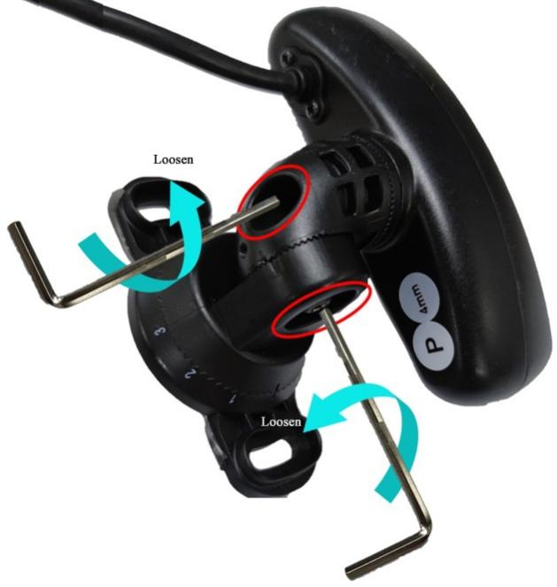

5. After adjusting the angle of the DMS camera up and down/left and right, make sure that the driver sits according to normal driving habits and posture, to meet the following conditions:

(1) Make sure the DMS camera has a low angle of view.

(2) Make sure that the driver's face appears in the middle of the video screen, the driver's face and body are vertical in the video screen, and the lower edge of the screen is below the driver's chest.

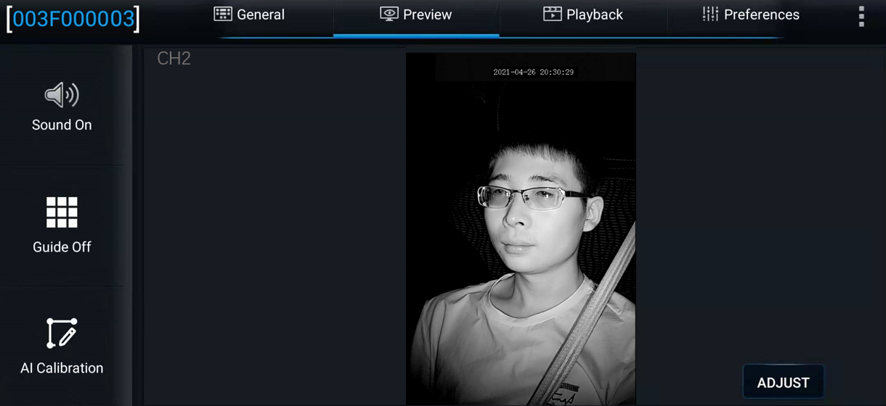

(3) Make sure that the fill light of the DMS camera illuminates the driver's face (fill light illuminating the seat belt is not allowed; otherwise, it will lead to overexposure of video).

(4) Make sure that there is no other object (for example, the steering wheel) in the DMS video screen that will obstruct the driver's face and the seat belt features.

6. Tighten the lower screw of the DMS camera mount and the screws at the left and right angle joints to ensure that the camera will not shake up and down or left and right.

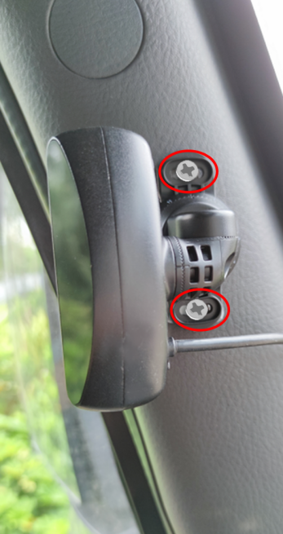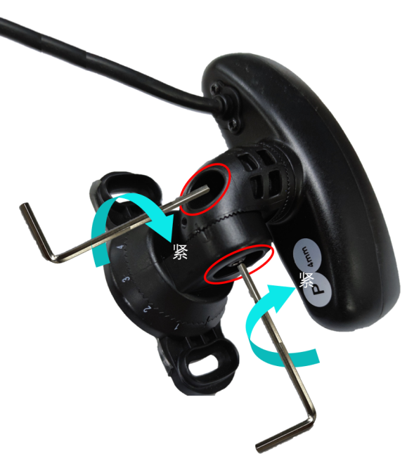

5.2.4.2 Installation Requirements for Glass-Mounted CA29M Camera

If the vehicle has an airbag on the A-pillar, and the A-pillar side mounted CA29M camera could not be mounted on the A-pillar, CA29M camera with glass mounting bracket can be chosen. The specific Installation process is as follows:

1. Firstly, according to the above-mentioned adjustment method for A-pillar side mounted CA29M, adjust the camera screen to make the driver's face facing forward (screen flip is not allowed). Then, on the premise that the 3M tape on the base of the glass mounted CA29M camera is not torn off, roughly determine the camera Installation position which shall meet the following requirements:

(1) The glass mounting bracket shall not be too far away from the A-pillar, otherwise it will obstruct the driver's view; the bracket base should be mounted parallel to the A-pillar.

(2) After the glass-mounted camera is installed, the upper part of the driver's body (above the chest) can be displayed on the camera screen. It shall be ensured that the seat belt features and face features can be seen, and the driver's face appears in the middle of the screen.

2. After determining the approximate position, tear off the 3M tape on the bracket base, and attach the bracket to the windshield in the direction parallel to the A-pillar.

* Note: When mounting, make the notched side of the bracket face upward, to facilitate camera angle adjustment after mounting, as shown in the following figure.

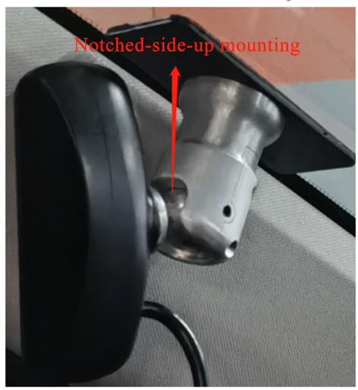

3. After attaching the base on the glass, adjust the spherical hinge by pushing the CA29M camera to ensure that the following requirements can be met according to the normal driving habits and sitting posture of the driver:

(1) Make sure that the driver's face appears in the middle of the video screen, and the lower edge of the screen is below the driver's chest.



(2) Make sure that the fill light of the DMS camera illuminates the driver's face (fill light illuminating seat belt is not allowed; otherwise, it will lead to overexposure of video).

(3) Make sure that there is no other object (such as steering wheel) in the DMS video screen that will obstruct the driver's face and the seat belt features.

4. Tighten the screws on the right side of DMS camera bracket to ensure that the camera will not shake.

5.2.4.3 Installation Requirements for CA29M Camera Vertically Mounted on Countertop

If the DMS camera is a countertop-mounted CA29M, the CA29M camera needs to be fixed above the instrument panel. The specific Installation method is as follows:

1. Firstly, according to the above-mentioned adjustment method for A-pillar side mounted CA29M, adjust the countertop-mounted CA29M camera screen to make the driver's face facing forward (screen flip is not allowed), and determine the camera Installation position which shall meet the following requirements:

(1) The countertop shall be flat and the camera can be fixed easily.

(2) The driver's face on the DMS screen is not obstructed by the steering wheel, and the upper part of the driver's body (above the chest) can be displayed on the screen. It shall be ensured that the seat belt features and face features can be seen, and the driver's face appears in the middle of the screen.

(3) DMS camera should be fixed in the middle of instrument panel. If this is not possible, the camera can be installed with rightward or leftward deflection, but the maximum deflection angle shall not exceed 30°.

2. After the Installation position is determined, fix the bracket on the instrument panel with self-tapping screws or 3M tape.

3. After the base is fixed, adjust the angle of DMS camera lens to ensure that the following requirements can be met according to the normal driving habits and sitting posture of the driver:

(1) Make sure that the driver's face appears in the middle of the video screen, and the lower edge of the screen is below the driver's chest.

(2) Make sure that the fill light of the DMS camera illuminates the driver's face (fill light illuminating seat belt is not allowed; otherwise, it will lead to overexposure of video).

(3) Make sure that there is no other object (such as steering wheel) in the DMS video screen that will obstruct the driver's face and the seat belt features.

4. Tighten the screws of DMS camera bracket to ensure that the camera will not shake.

5.2.5 Calibration Requirements

Log in to the “Veyes” App.

**1. Click [Preview] on the homepage to enter the preview interface.**

Double-click the driver channel to enter the main-stream full screen.

Adjust the angle of the DMS camera so that the driver's face appears in the middle of the screen and the lower edge of the screen is below the driver's chest.

Make sure that the fill light of the DMS camera faces toward the driver's face (the fill light shall not face toward the seat belt; otherwise, it will lead to overexposure of video).

Make sure that there is no other object (such as steering wheel) in the DMS video screen that will block the driver's face and the seat belt features.

2. Click [AI Calibration] for calibration selection.

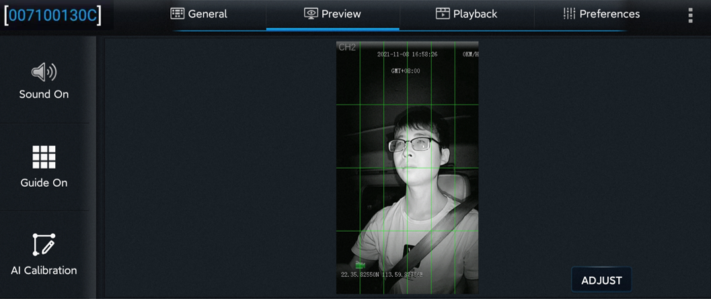

3. Select [DMS] for calibration.

4. Select corresponding channel of the DMS camera (select channel 3 here).

5. Click [Calibration] to move on to the next step.

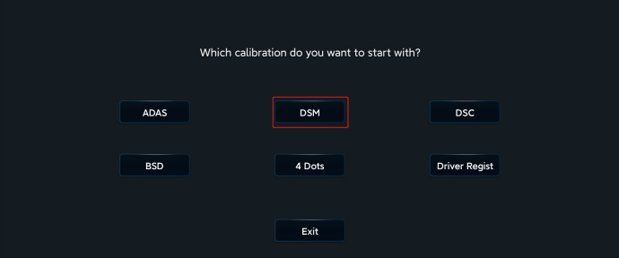 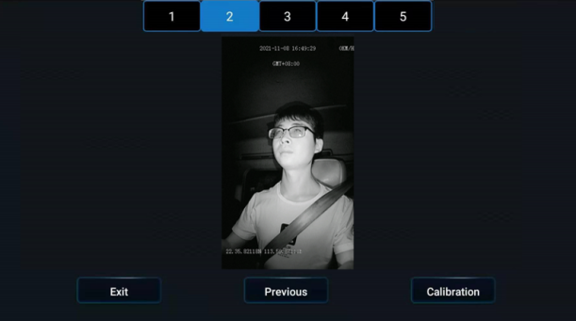

6. Confirm the prompts — click [Next] to move on to the next step.

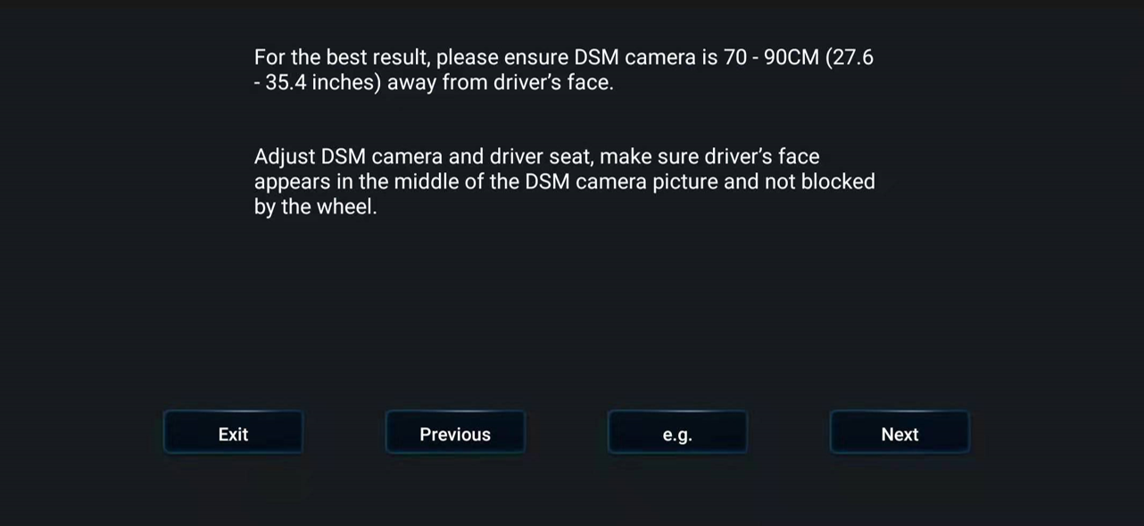

**7. Installation location of DMS camera**

The left A-pillar, the right A-pillar, the front side of the countertop, and the lateral side of the countertop are available. If you have any questions, please click each option in turn, and refer to the legend and description on the right.

After selecting the corresponding Installation method, the software automatically associates the calibration method with the Installation method, not requiring any manual operation (for Installation on the left A-pillar, the right A-pillar, and the lateral side of the countertop, the lateral side calibration is applied, and for the Installation on the front side of the countertop, the front side calibration is applied).

(This Step is very important, and the selected Installation method must be consistent with the actual Installation method)

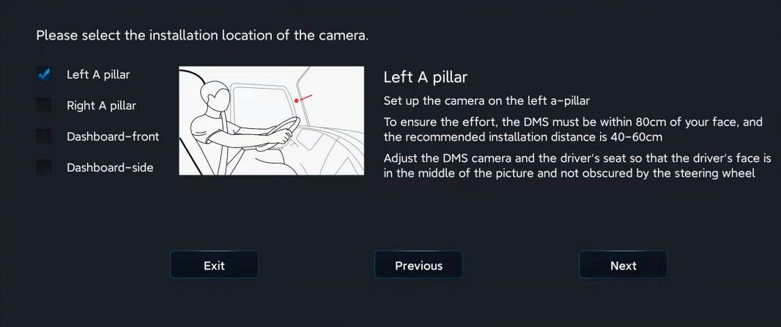

*Note:

Before clicking [Next] to start formal calibration, the driver shall sit in the normal driving posture and **look straight ahead**.

8. Click [Next] to move on to the next Step for automatic face calibration.

During calibration, make sure that the driver sits still according to normal driving habits and posture and looks straight ahead.

In the process of side calibration, the intelligent algorithm will automatically learn the driver's head deflection angle and the positions of feature data of the driver's face. If the driver moves his head during the calibration, the calibration will restart automatically.

*Note:

For Installation on the left A-pillar, the right A-pillar, and the lateral side of the countertop, the human face and the camera must form a certain angle to complete the calibration.

For Installation on the front side of the countertop, the human face must be in front of the camera to complete the calibration.

The driver sits and waits for the equipment to be calibrated automatically. When the value of NUM reaches 301 in the mode of side Installation and side calibration (51 in the mode of front Installation and front calibration), the calibration frame turns from blue to red, and then the calibration ends.

Calibration is ongoing:

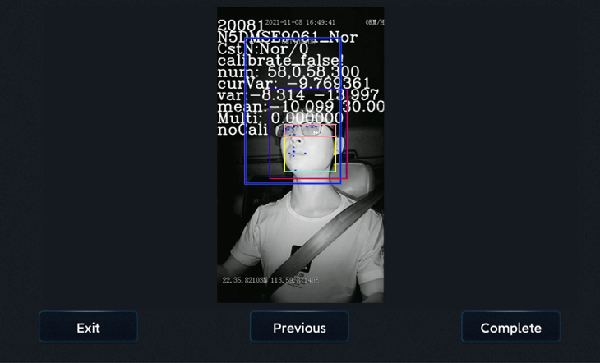

Calibration is completed:

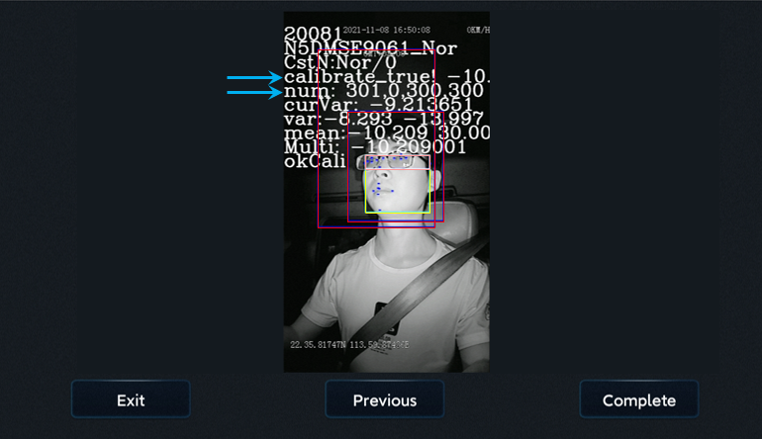

Click [Finish] to complete the calibration and exit the calibration mode.

5.3 ADKIT Installation and Calibration

If the X1N-H0401+ADKIT solution is used to realize the ADAS+DMS function, the ADKIT shall be installed, which can only be installed on the countertop.

5.3.1 Requirements for Installation Position

ADKIT itself is bulky and suitable for Installation on the countertop of medium and large vehicles. The Installation shall meet the following conditions.

1. The desktop is flat and the camera can be fixed easily.

2. The face in the DMS channel screen is not blocked by the steering wheel. If necessary, it is suggested to install a padding bracket.

3. The favorable distance from the lens to the human face is within 70 - 90 cm.

4. It can be installed on the countertop in front of the driver, or on the countertop on the left or right side of the driver; however, when it is installed on the side of the countertop, the horizontal distance between ADKIT and the center of the steering wheel shall be ≤ 30cm, and the maximum deflection angle shall not exceed 30°.

5.3.2 Installation Steps

1. Tighten the base screws

Tighten the base screw after getting the ADKIT camera.

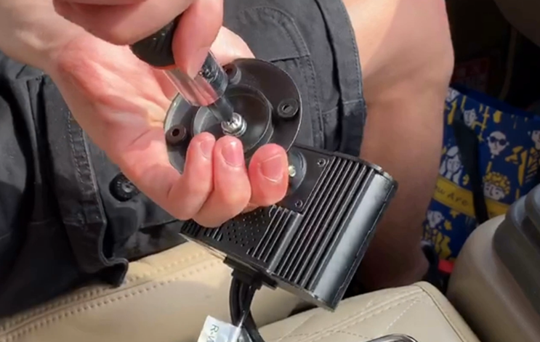

2. Find a suitable Installation location, and adjust the camera Installation angle.

Find an appropriate Installation location for ADKIT according to the above requirements, and power on the device; then, adjust the lens angle and deflection direction through the real-time preview screen (the auxiliary line on the EasyCheck App can be opened), so as to enable the image to meet the following requirements:

① Make sure that the DMS camera has a low angle of view.

② Adjust the angle of the DMS camera up and down, and left and right, to ensure that the driver's face appears in the middle four grids of the video screen and the lower edge of the screen is below the driver's chest.

③ DMS channel fills in light on the human face;

④ No feature value of the human face is blocked by the steering wheel, and the human face is distanced from the steering wheel; in addition, the steering wheel is located within two lower right grids of the screen;

⑤ When simulating people with a height of 165cm, 175cm, and 185cm by the sitting posture, the main characteristic parts of the human face (eyes, nose, mouth, chin) are still within the four grids in the middle.

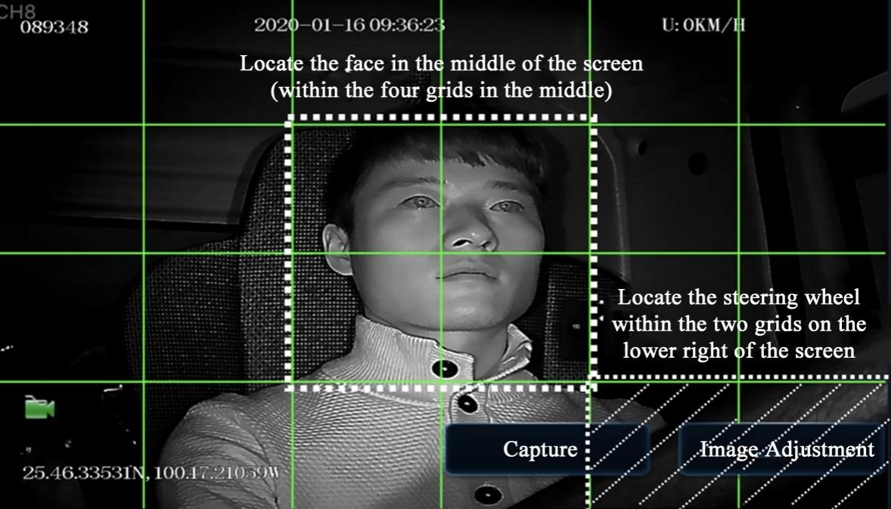

3. Tighten the base fixing screws

After confirming the proper Installation position through the preview screen, fix the 4 screws of the ADKIT base to the countertop in turn (in diagonal) to ensure that the ADKIT will not shake.

4. Fixed ADKIT camera

After fixing the base, confirm the image effect according to the preview screen again, which shall meet the requirements of Installation Step 2. then, fasten the ADKIT camera with an Allen screwdriver, ensuring that the camera cannot be easily tilted.

5.3.3. Calibration Requirements

Log in to the “Veyes” App.

1. Click [**Preview]** on the homepage to enter the preview interface.

Double-click the driver channel to enter the main-stream full screen.

2. Click [**AI Calibration]** for calibration selection.

3. Select [**DMS]** for calibration.

4. Select the corresponding channel of the DMS camera (select **Channel 5** here).

5. Click [**Calibration]** to move on to the next step.

6. Click [**Next]** to enter the next step.



7. Installation location of DMS camera

Installation on the front side and the lateral side of the countertop are available. If you have any questions, please click each option in turn, and refer to the legend and description on the right.

After selecting the corresponding Installation method, the software automatically associates the calibration method with the Installation method, not requiring any manual operation (for Installation on the lateral side of the countertop, the lateral side calibration is applied, and for the Installation on the front side of the countertop, the front side calibration is applied).

(This Step is very important, and the selected Installation method must be consistent with the actual Installation method)

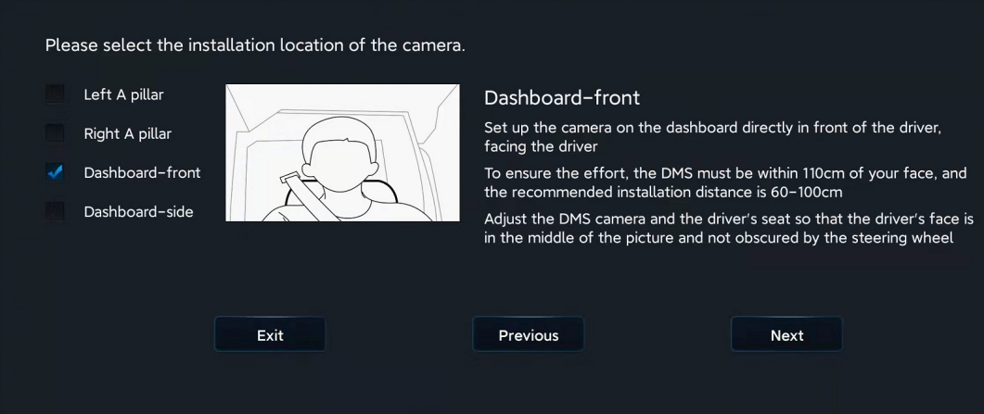

*Note:

Before clicking [Next] to start formal calibration, the driver shall sit in the normal driving posture and **look straight ahead**.

Never select front calibration if side Installation is selected. The driver shall turn the head sideways to face toward the camera to complete the calibration.

8. Click [Next] to move on to the next Step for automatic face calibration.

During calibration, make sure that the driver sits still according to normal driving habits and posture and looks straight ahead.

In the process of side calibration, the intelligent algorithm will automatically learn the driver's head deflection angle and the positions of feature data of the driver's face. If the driver moves his head during the calibration, the calibration will restart automatically.

*Note:

For installation on the lateral side of the countertop, the human face must be in a certain angle to the camera to complete the calibration.

For Installation on the front side of the countertop, the human face must be in front of the camera to complete the calibration.

The driver sits and waits for the equipment to be calibrated automatically. When the value of NUM reaches 301 in the mode of side Installation and side calibration (51 in the mode of front Installation and front calibration), the calibration frame turns from blue to red, and then the calibration automatically ends.

Calibration is completed:

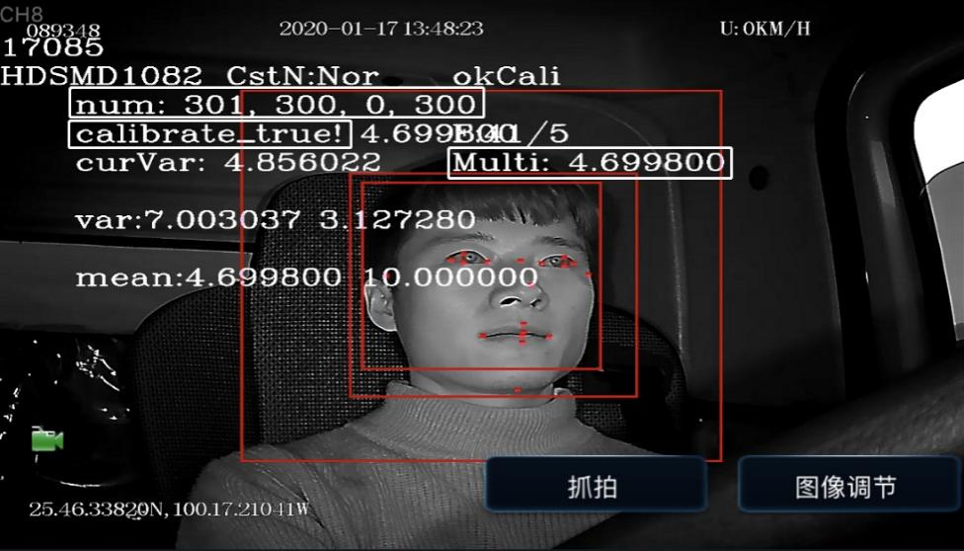

Click [Finish] to complete the calibration and exit the calibration mode.

**\*Description**

If the ADAS algorithm is also used in the ADKIT solution, the ADAS lens (CA20S) shall be connected to the ADKIT, instead of to MDVR. The Installation requirements for ADAS lenses are detailed in 5.1.

5.4 BSD Installation and Calibration

5.4.1 Top-view Installation and Calibration

Top-view Installation consists of Installation on the front, left and right side of the bus above the windscreen. Top-view Installation on the left and right side has the same principles and steps with Mini C24-MA used. Please refer to the picture below for Installation effect.

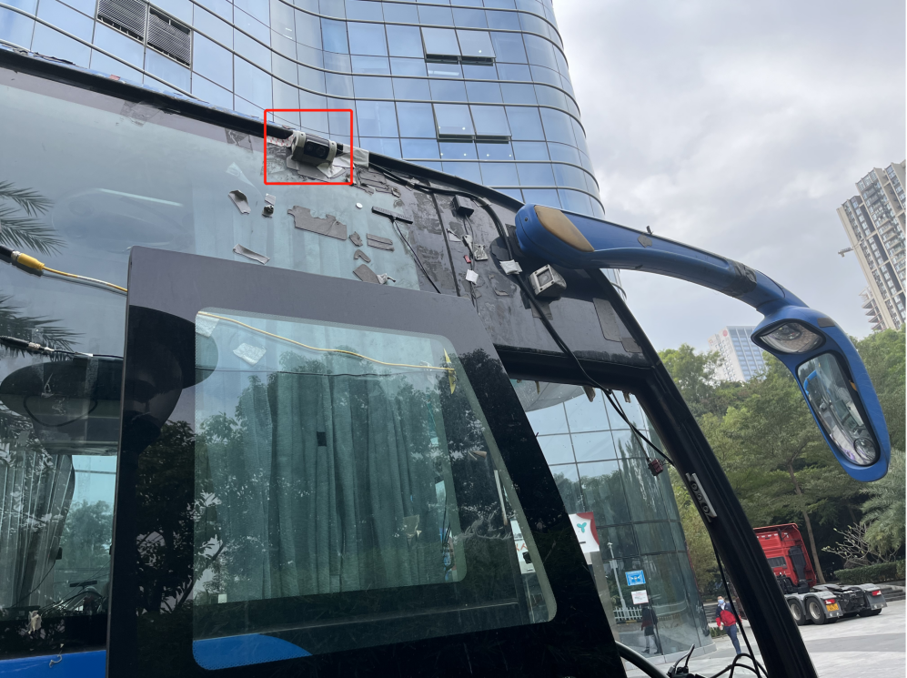

**[Installation position]**

The camera must be installed on the front, left and right side of the bus above the windscreen, with the Installation height being 210-400 cm, preferably 270 to 300 cm. While choosing the Installation position, you’d better avoid the camera being too close to the side mirror. Otherwise, it will cause the image to be blocked by the side mirror.

**[Imaging adjustment]**

Rotate ball head of the camera to ensure the image after Installation can cover the pedestrian detection area which is in the center of the image.

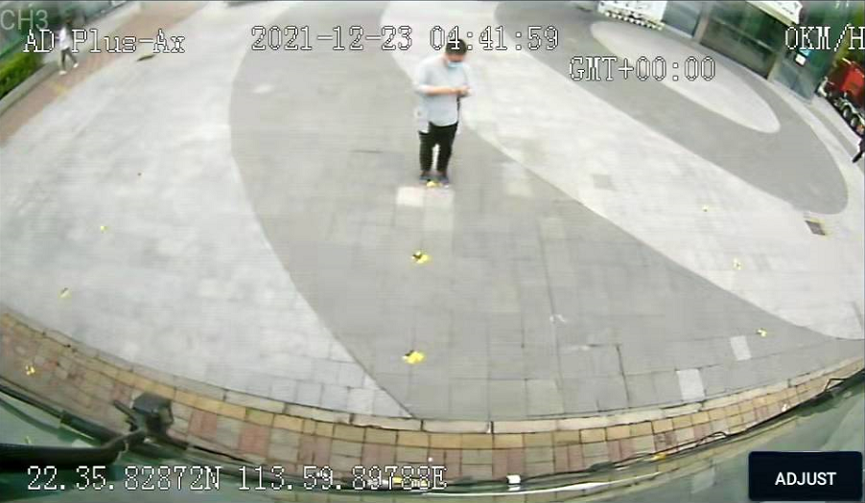

**[Calibration and Debugging]**

**Step 1:** Connect the mobile phone to the device hotspot, enter EasyCheck APP, type in Username and Password, and click Login.

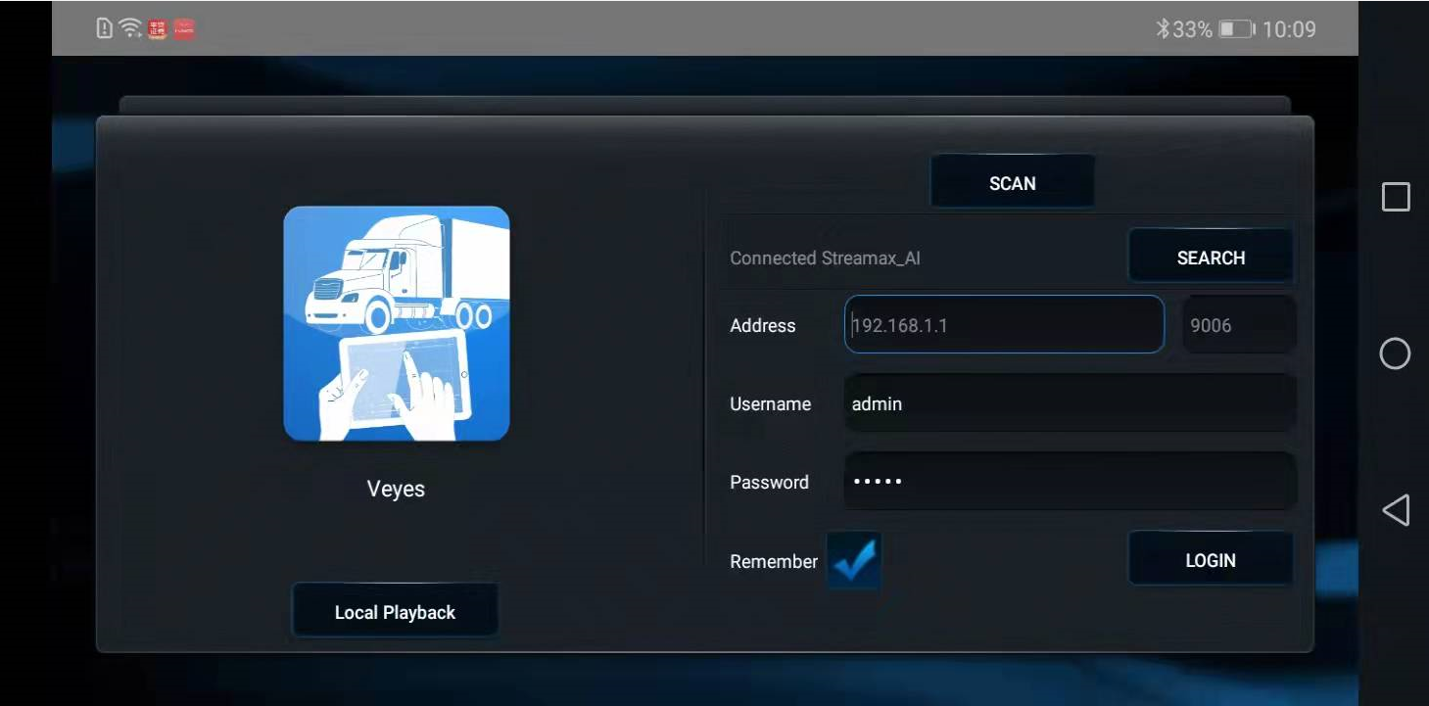

**Step 2:** After logging in, click **[Preview]** to display the channel screen. Then click **[AI Calibration].**

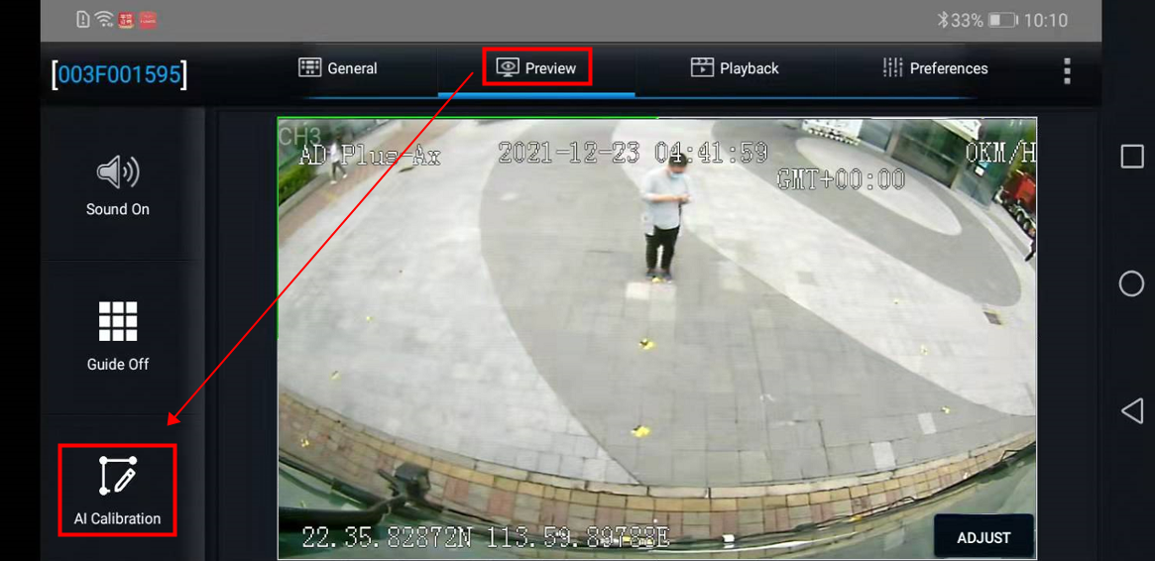

**Step 3:** Click **[BSD].**

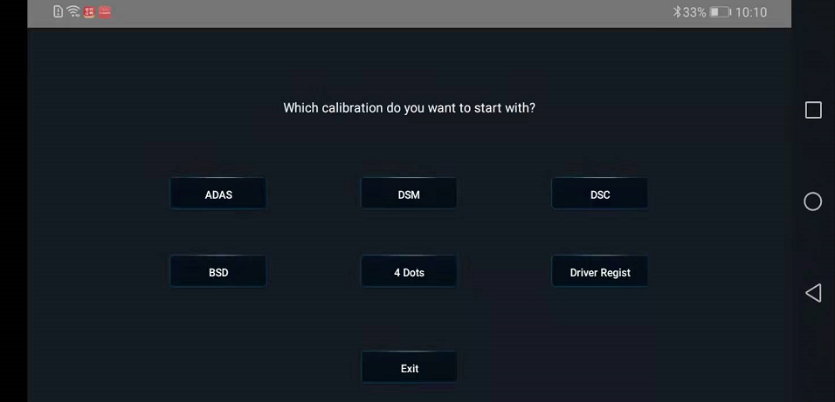

**Step 4:** Click **[Simple Left Top View BSD].**

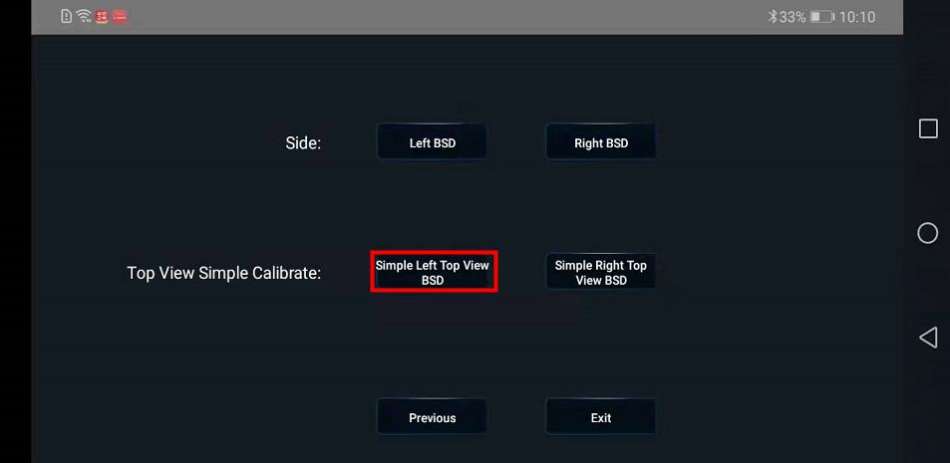

**Step 5:** Select the channel to which the camera is connected.

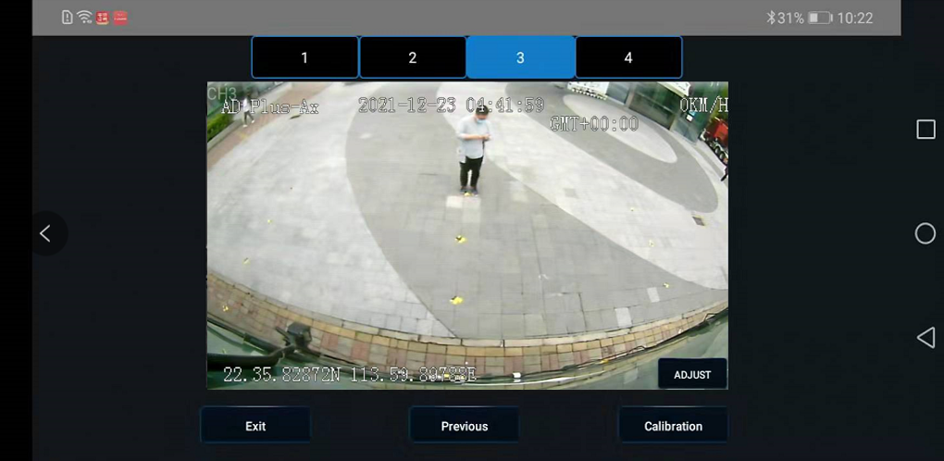

**Step 6:** Place the yellow line close to the bus passenger side, and type in the Installation height.

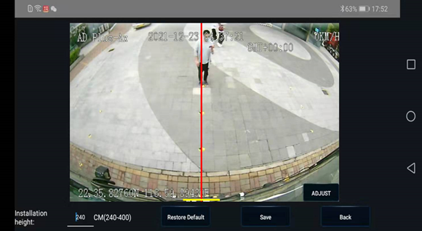

**Notice:**

When rotating ball head of the camera, it is required that the image bottom shall be close to the bottom edge of bus passenger side.

Do not make the bus body disappear on the screen. Otherwise, the right blind spot will not be covered.

Do not make the vehicle body appear too much at the bottom of imaging screen. Otherwise, it will reflect infrared light at night and cause overexposure to result in identification failure.

5.4.2 Side-mounted Calibration

Side-mount means Installation on the left and right side of the bus. Principles and steps of Installation and calibration are the same. Here the left side-mount is selected with CA24S used. Please refer to the picture below for Installation effect.

It is required that the Installation height of BSD Camera should be 100-250 cm. The distance between BSD Camera and the front of the bus shall be 100-170 cm. And the best Installation height for side-mounted BSD Camera is 195±15cm.

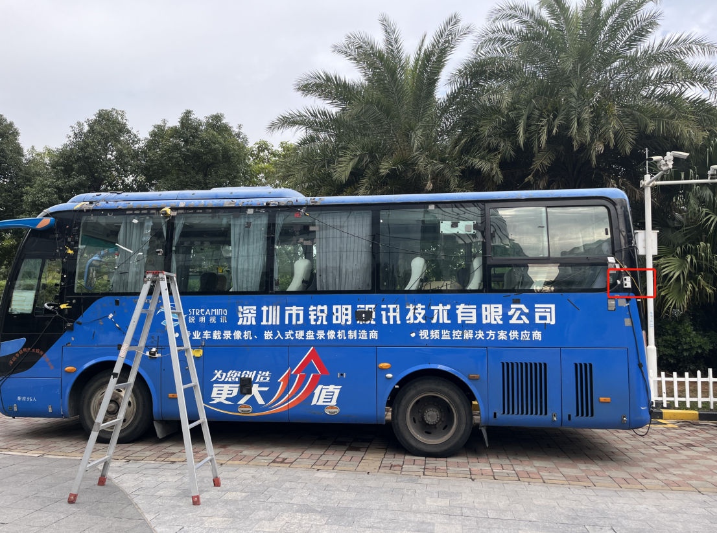

Start calibration.

**Step 1:** Connect the mobile phone to the device hotspot, enter EasyCheck APP, type in Username and Password, and click Login.



**Step 2:** After logging in, click **[Preview]** to display the channel screen. Then click **[AI Calibration].**



**Step 3:** Click **[BSD].**



**Step 4:** Click **[Simple Left Top View BSD].**

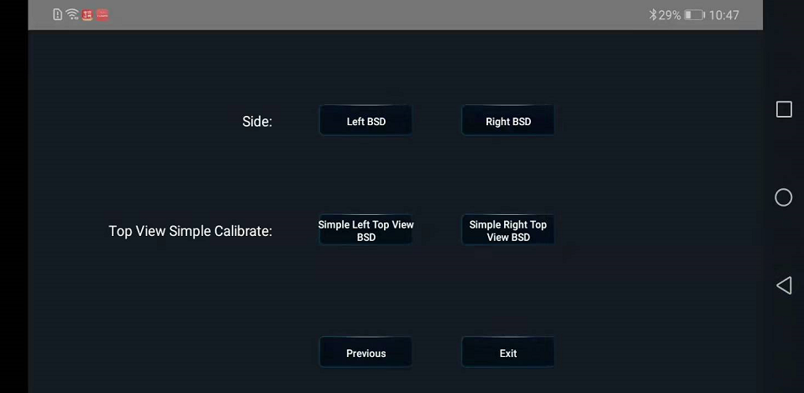

**Step 5:** Select the channel to which the camera is connected.

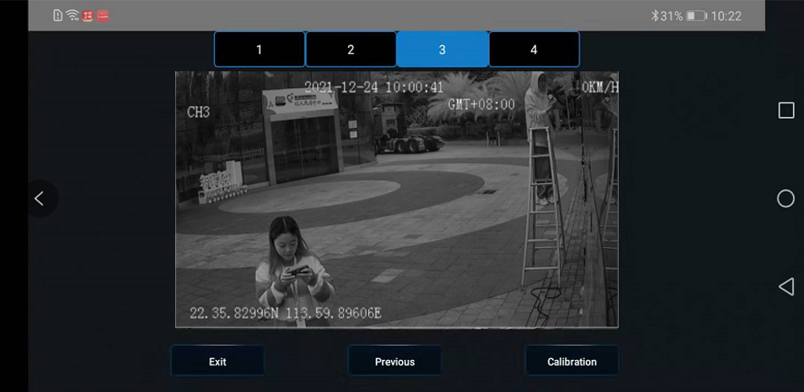

**Step 6:** Place the **traffic cone** at adistance of 2-3 meters from the front of bus passenger side **(The specific location of traffic cone shall be determined by the bus with the average height of driver’s visual field taken. The driver shall sit in the bus to check the size of blind spot, calibrate the blind spot om the screen, and** [**take**](javascript:;)[**this**](javascript:;)[**as**](javascript:;)[**the**](javascript:;)[**standard**](javascript:;)**)**. The [horizontal](javascript:;) [distance](javascript:;) between the traffic cone and bus passenger side shall be 0.8 meters.

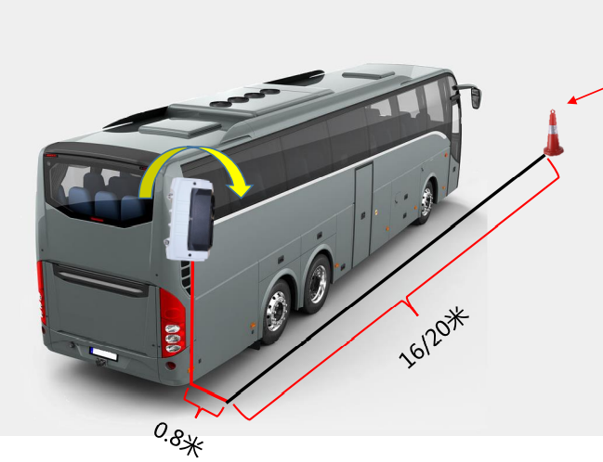

16-20M

0.8M

Place the red line close to the bus passenger side, and yellow line to the bottom edge of traffic cone (here the human feet). Click Save after completing the adjustment.

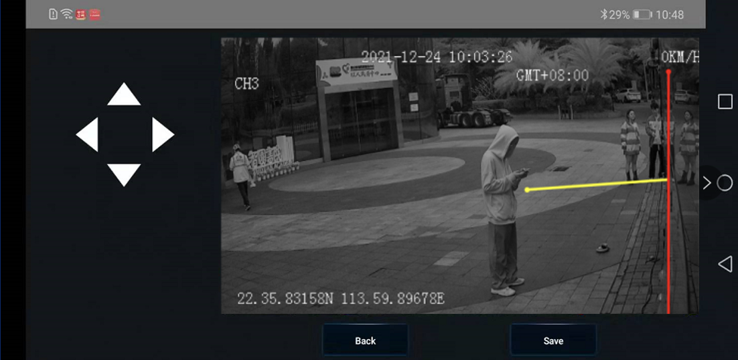

Then the screen will display the Installation height of BSD Camera, and the distance from BSD camera to the front of bus passenger side.

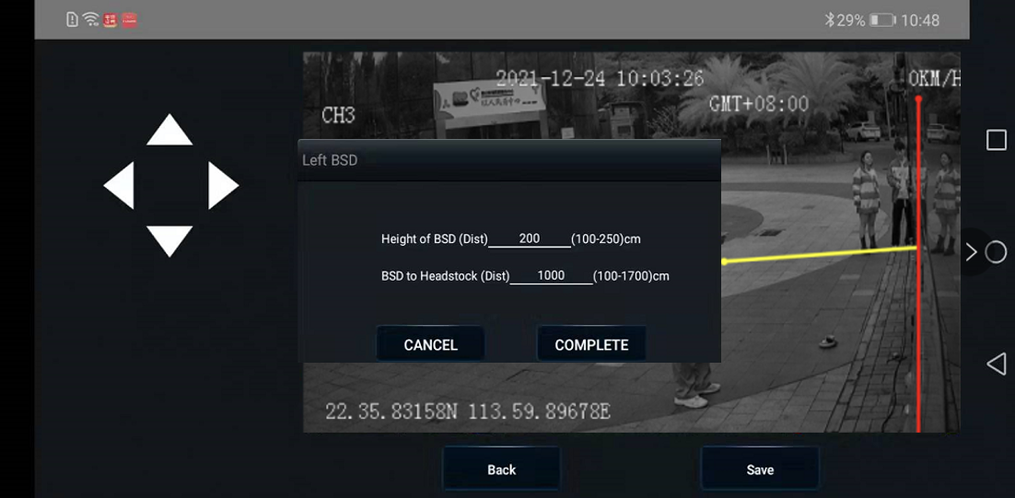

Enter the exact number of Installation height and distance respectively, and click Finish.

5.4.3 Blind Spot in Front of the Vehicle

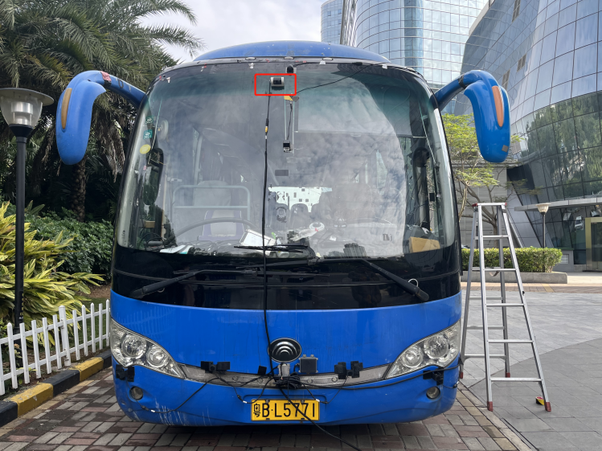

**Step 1:** Connect the mobile phone to the device hotspot, enter EZINSTALLER, type in Username and Password, and click Login.

**Step 2:** Click **[Next]** to display the channel screen. Select **[AI Alarm Type]**, then **[Front Blind Spot]**,and click the setting button to start calibration.

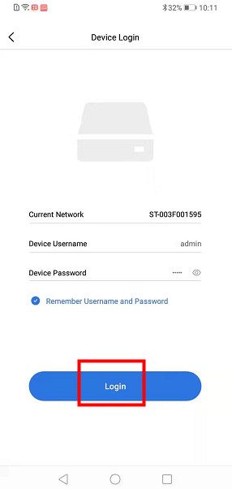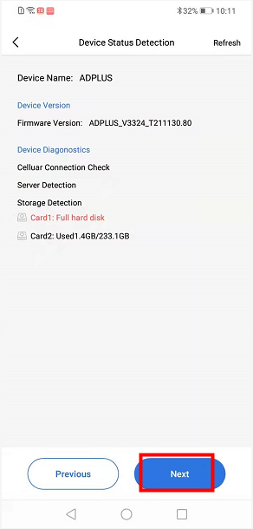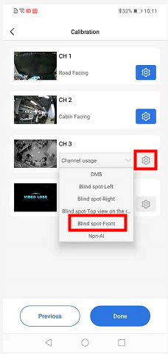

**Step 3:** Draw the blind spot by moving four points to form a rectangle **(The area drawn shall cover all blind spots in front of the bus)**.

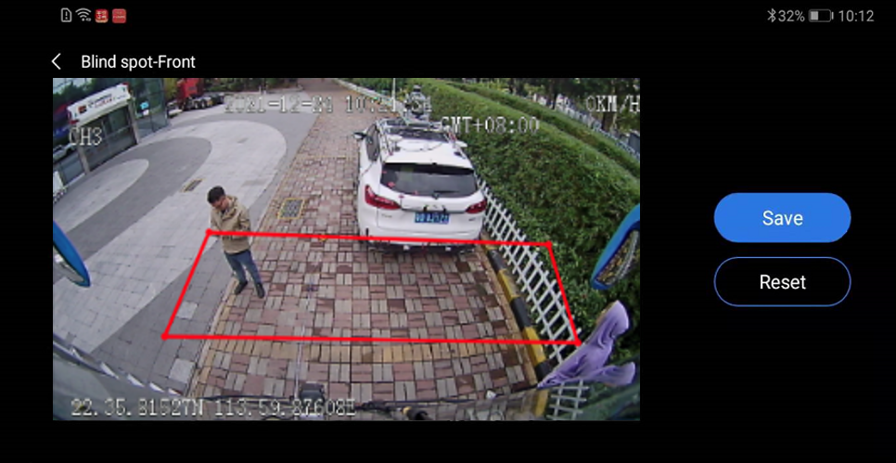

6. Process Requirements

6.1 Treatment Standard of Unused Connection Wire Ends

1.All unused signal connection wire ends must be wrapped. Refer to the figure below for the standard treatment process requirements.

2. Unused aviation connectors must also be wrapped.

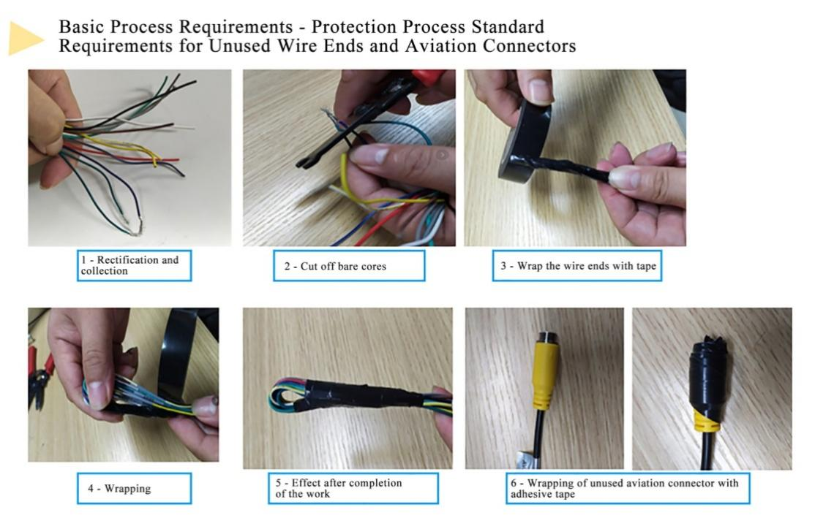

6.2 Connection Process of Aviation Connector

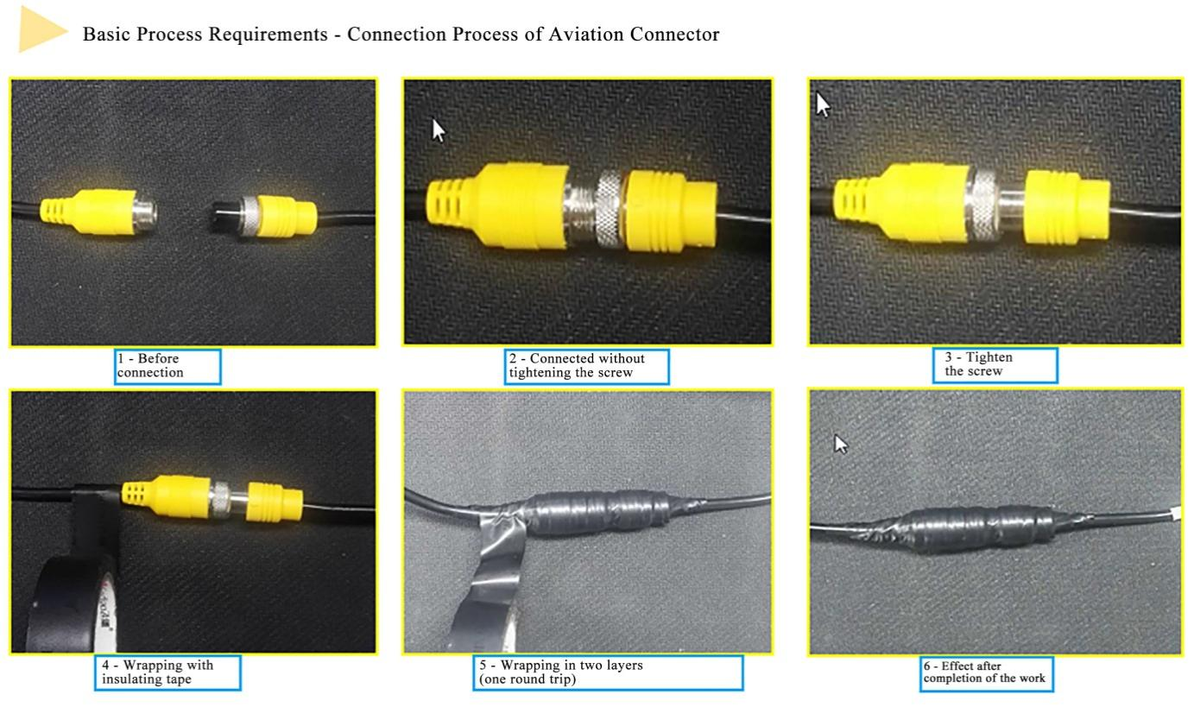

6.3 Requirements of Opening for Wiring

6.3.1 Interior Opening for Wiring of Vehicle

① If the mode of opening for wiring is adopted, a rubber sleeve shall be additionally set at the opening to protect the cables from being worn out by the sharp part of the opening.

② To ensure aesthetic wiring, the mode of concealed wiring where possible and arrangement of surface wiring in corrugated conduits shall be adopted.

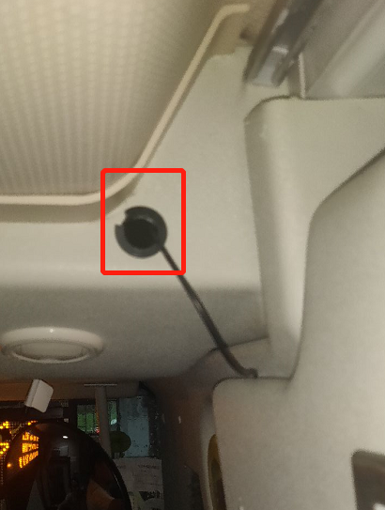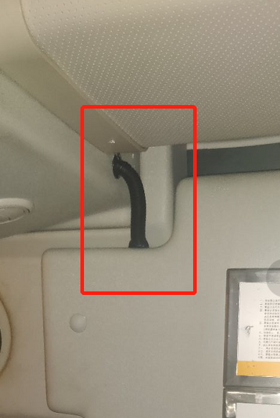

6.3.2 Exterior Opening of Car-body- Opening for Installation of Tail Harness of Camera

The two requirements described in 6.3.1 shall be met. In addition, waterproof adhesive shall also be applied at the opening to prevent rainwater from entering the vehicle.

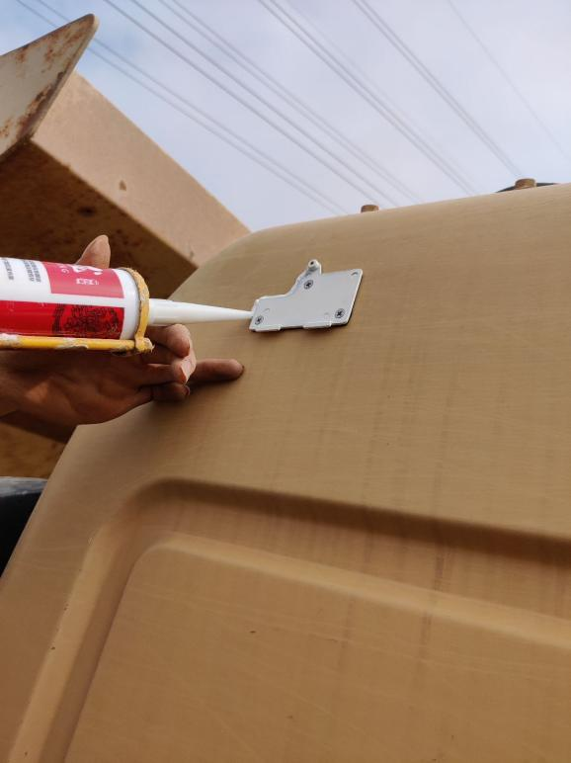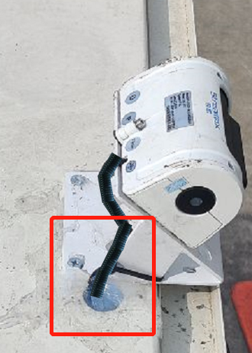

① At the screwing part of camera and the opening for Installation of tail harness on the exterior of the car-body, glass sealant shall be applied for waterproofing.

② For the purpose of aesthetics, the color of glass sealant shall be the same as or be similar to the car-body.

7. Acceptance and Cleaning

7.1 Cleaning

Clean up the Installation site, collect and take away tools and waste separately, and put the original articles in the vehicle to their original place, and then the Installation work ends.



7.2 Installation Acceptance

1.Conduct acceptance for the Installation details and parameter setup item by item according to the acceptance list provided by the customer.

(1) Focus on inspection of parameter setup, and save screenshots.

(2) Focus on inspection of video images, and capture and save videos.

(3) Allow the driver to drive the vehicle for a short distance to check whether the ADAS/DMS/BSD camera functions normally.

2. Take pictures of all the equipment and the center console after Installation.

(1) Take pictures of the Installation positions of all items.

(2) Take a picture of the rendering inside the cabin after Installation.